REPORT TO EXECUTIVE MAYOR: 12 SEPTEMBER 2014
File No.:5/1/1/1[14/15]
Author: CITY MANAGER (ANDILE FANI)/VP

STATEMENT OF FINANCIAL PERFORMANCE AND THE IMPLEMENTATION OF THE 2014/15 BUDGET FOR THE PERIOD ENDING 31 AUGUST 2014

1. PURPOSE
The purpose of the report is for the Executive Mayor to consider and note the statement of financial performance and the implementation of the 2014/15 budget of the Buffalo City Metropolitan Municipality for the period ending 31 August 2014.

2. AUTHORITY
Executive Mayor

3. LEGAL / STATUTORY REQUIREMENTS
3.1. The Constitution of the Republic of South Africa, 1996
3.2 Municipal Finance Management Act No 56, 2003 Chapter 7, Section 71
3.3. Municipal Budget and Reporting Regulations

4. PRESENTATION OF THE REPORT ON THE STATEMENT OF FINANCIAL
PERFORMANCE AND THE IMPLEMENTATION OF THE 2014/15 BUDGET FOR
THE PERIOD ENDING 31 AUGUST 2014 IN TERMS OF THE MUNICIPAL
BUDGET AND REPORTING REGULATIONS
In terms of Section 71 of the Municipal Finance Management Act No 56, 2003, “the Accounting Officer of a municipality must by no later than 10 working days after the end of each month submit to the Mayor of the municipality and the relevant provincial treasury a statement in the prescribed format on the state of the municipality’s budget”.

The report which follows here below follows the legislative requirements of the Municipal Budget and Reporting Regulations.
TABLE OF CONTENTS

PART 1: ANNUAL BUDGET

5. | RESOLUTIONS | 5
6. | EXECUTIVE SUMMARY | 6
7. | IN-YEAR BUDGET STATEMENT TABLES | 9

PART 2: SUPPORTING DOCUMENTATION
8. | DEBTORS’ ANALYSIS | 18
9. | CREDITORS’ ANALYSIS | 23
10. | INVESTMENT PORTFOLIO ANALYSIS | 25
11. | ALLOCATION AND GRANT RECEIPTS AND EXPENDITURE | 28
12. | COUNCILLOR ALLOWANCES AND EMPLOYEE BENEFITS | 33
13. | MUNICIPALITY FINANCIAL PERFORMANCE | 40
14. | MUNICIPAL ENTITY FINANCIAL PERFORMANCE | 46
15. | CAPITAL PROGRAMME PERFORMANCE | 46
16. | OTHER SUPPORTING DOCUMENTS | 51
17. | INCOME AND EXPENDITURE REPORTS FOR DIRECTORATE OF HEALTH AND PUBLIC SAFETY & COMMUNITY SERVICES | 53
18. | MUNICIPAL MANAGER’S QUALITY CERTIFICATION | 55

LIST OF TABLES

TABLE 1 | Performance Summary | 6
TABLE 2 | C1: Monthly Budget Statement Summary | 9
TABLE 3 | C2: Monthly Budget Statement – Financial Performance (standard classification) | 10
TABLE 4 | C3: Monthly Budget Statement – Financial Performance (Revenue and expenditure by municipal vote) | 11
TABLE 5 | C4: Monthly Budget Statement – Financial Performance (Revenue by Source and Expenditure by Type) | 12
TABLE 6 | SC1: Material Variance Explanations for Revenue By Source and Expenditure by Type | 13
TABLE 7 | C5: Monthly Budget Statement – Capital Expenditure (municipal vote, standard classification and funding) | 14
TABLE 8 | C6: Monthly Budget Statement – Financial Position | 15
TABLE 9 | C7: Monthly Budget Statement – Cash Flow | 16
TABLE 10 | SC3 Monthly budget statement Aged Debtors | 18
TABLE 11 | Debtor’s Age Analysis as at 31 August 2014 | 19
TABLE 12 | Age Analysis per Category Type as at 31 August 2014 | 20
TABLE 13 | Cumulative Nett Billing, Receipts and Debtors Collection Ratio per month from 2012/13 to 2014/15 financial year | 21
TABLE 14 | Analysis of Government Debt as at 31 August 2014 | 22
TABLE 15 | SC4 Monthly budget Statement Aged Creditors | 23
TABLE 16 | 20 Highest Paid Creditors | 24
TABLE 17 | SC5 Monthly budget Statement – investment portfolio | 25
TABLE 18 | SC7 Monthly budget Statement – transfers and grants expenditure | 28
TABLE 19 | Spending per Conditional Grant Funding Allocation | 29
TABLE 20 | SC8: Monthly Budget Statement – Councillor and Staff Benefits | 34
TABLE 21 | Analysis of Overtime | 35
TABLE 22 | Overtime Per Cost Centre | 35
TABLE 23 | Analysis of Standby & Shift | 38
TABLE 24 | Analysis of Temporary Staff | 39
TABLE 25 | Analysis of Councillor Costs | 39
TABLE 26 | Statement of Financial Performance for the period ending 31 August 2014 | 41
TABLE 27 | Repairs and Maintenance per Directorate | 46
TABLE 28 | SC12 Monthly budget Statement – capital expenditure trend | 46
TABLE 29 | Capital Expenditure per Funding Source against Budget | 47
TABLE 30 | Actual Expenditure per Service against Budget | 48
TABLE 31 | Actual Expenditure per Directorate against Budget | 48
TABLE 32 | SC13a Monthly budget Statement – capital expenditure on new assets by asset class | 49
TABLE 33 | SC13b Monthly budget Statement – capital expenditure on renewal of existing assets by asset class | 50
TABLE 34 | Operating Projects per Directorate | 51
TABLE 35 | Operating Projects per Funding Source | 52
TABLE 36 | Health & Public Safety – Cost Analysis | 53
TABLE 37 | Community Services – Cost Analysis | 54

PART 1: IN-YEAR REPORT

5. RESOLUTIONS
It is recommended that:

- The Executive Mayor considers and notes the report on the statement of financial performance and the implementation of the 2014/15 budget for the period ending 31 August 2014 including supporting documentation attached as Annexure A to E.

- The Executive Mayor notes the spending rate on capital and operating projects as well as reasons for such as indicated in section 15.2 and 16.1 respectively of this report.

- The Executive Mayor notes the year to date collection rate for the period ending 31 August 2014 of 86% and the twelve (12) months average of 93%.

---------------------- -----------------------
CITY MANAGER DATE

6. EXECUTIVE SUMMARY ON THE IMPLEMENTATION OF THE BUDGET AND THE FINANCIAL STATE OF AFFAIRS OF THE MUNICIPALITY FOR THE PERIOD ENDING 31 AUGUST 2014

6.1 Dashboard / Performance Summary
Table 1: Performance Summary
OVERALL OPERATING RESULTS |  | CASH MANAGEMENT
Income | R1,010,363,925 | Bank Balance | R 186,124,309
Expenditure | R 782,376,066 | Call investment deposits | R 2,163,579,073
Operating Surplus | R 227,987,858 | Cash and cash equivalents | R 2,349,703,382
 |  | Total value of investments | R 2,173,471,433
 |  | Total investments - own funds | R 1,694,426,959
 |  | Total grants | R 479,044,474
 |  | Total Loans | R 603,415,392
DEBTORS |  | SURPLUS / (DEFICIT) PER SERVICE
Total debtors book | R 962,929,012 | Water | R 33,937,331
Total debtors - Government | R 11,905,868 | Electricity | -R23,322,231
Total debtors - Business | R 107,463,408 | Refuse | R 31,479,654
Total debtors - Households | R 711,814,567 | Sewerage | R 9,819,789
Total debtors - Other | R 131,745,169
Total debt written off | R 119,080
CAPITAL EXPENDITURE |  | OPERATING PROJECTS EXPENDITURE
Capital Expenditure as a % of Approved Budget (2013/14: 2%, R856.36 million) | 4%  R41.28 million  (4%  R45.32 million incl. vat on conditional grant funding) | Operating Expenditure as a % of Approved Budget (2013/14: 2%, R357.01 million) | 9%  R26.01 million  (9%  R26.03 million incl. vat on conditional grant funding)
FINANCIAL |  | HUMAN RESOURCES
Operating Surplus for the period | R 227,987,858 | Total staff complement | 4,381
12 months average collection ratio | 93% | Staff Appointments | 125
YTD Grants and subsidies | R 285,461,218 | Staff Terminations | 30
Debtors to Revenue | 14.91% | Total overtime paid (YTD) | R6,601,737
Percentage of Creditors paid within terms | 100% | Allowances and benefits- Councilors | R7,535,638
Current ratio | 2.97:1 | Salary bill - Officials | R181,696,088
Total debt to Total assets | 4.31% | Workforce costs as a % of income | 18%
Capital Charges to Operating Expenditure | 16.39%

6.2 Liquidity position
Buffalo City Metropolitan Municipality’s liquidity is considered relatively sound as the Current Ratio is 2.97:1 which indicates the ability of Municipality’s current assets to cover its current liabilities. Debtors constitute 22% of the current assets, inventory constitutes 3% and cash & cash equivalents comprise 73% of the current assets.
6.3 Collection Rate and Outstanding Debtors
The debtor’s collection rate for the average twelve months ending 31 August 2014 is 93% (2013/14: 92.52%) and the year to date collection rate for the two (2) months is 86% (2013/14: 71.01%).

Total debtors book as at 31 August 2014 amounts to R962.93 million (2013: R866.94 million). (Households: R711.81 million, Business: R107.46 million, Government: R11.91 million, Other: R131.75 million). The ratio of debtors to revenue is 14.91%. The debtors’ age analysis report is reflected on Annexure B – SC3.

6.4 Capital Expenditure
BCMM has spent 4% inclusive of reclaimed vat (2013/14: 2%) of its 2014/15 rollover adjusted capital budget of R1.06 billion (2013/14: R856.36 million) with expenditure of R45.32 million (2013/14: R14.98 million) as at 31 August 2014. This reflects an improvement when compared to the same period in the previous financial year.
A detailed schedule of the capital projects expenditure is outlined in Annexure E.

6.5 Operating projects
The Metro has spent 9% inclusive of reclaimed vat (2013/14: 2%) of its 2014/15 rollover adjustment budget of R288.44 million (2013/14: R357.01 million) with expenditure of R26.03 million as at 31 August 2014 (2013/14: R7.58 million). This reflects an improvement when compared to the same period in the previous financial year.

A detailed schedule of the operating projects expenditure is outlined in Annexure D.

6.5 Expenditure on DoRA Current Allocation
The total expenditure inclusive of reclaimed vat on conditional grants DoRA
allocation as at 31 August 2014 amounts to R39.22 million (2013/14: R16.51 million)
which is 5% (2013/14: 2%) of R714.18 million (2013/14: R729.64 million). This
reflects an improvement when compared to the same period in the previous financial
year.

Urban Settlement Development Grant (USDG) funded projects
BCMM has spent 6% inclusive of reclaimed vat (2013/14: 3%) of its 2014/15 USDG budget of R673.29 million (2013/14: R613.31 million) with expenditure of R38 million (2013/14: R15.63 million) as at 31 August 2014.This reflects an improvement when compared to the same period in the previous financial year.

6.6 Cash and Cash Equivalents
The cash and cash equivalents of the City as at 31 August 2014 are R2.35 billion made up of conditional grants amounting to R479.04 million and own funds of R1.69 billion. This funding is invested with various financial institutions in compliance with the MFMA. Refer to Annexure A – C7 for the cash flow statement as well as Annexure B – SC5 for the investment portfolio breakdown.

6.7 Outstanding Creditors
The Metro is paying its creditors within 30 days as stipulated by the MFMA except where there are disputes between the City and the creditor. The age creditor’s analysis is reflected in Annexure B –SC 4.

6.8 Long-Term Debt Profile
The total long term borrowings of the municipality as at 31 August 2014 amounts to R603.42 million (Refer to Annexure C for the schedule of borrowings).

The ratio of total debt to total assets is 4.31% and the total debt to revenue ratio is 14.70% as at 31 August 2014.

7. IN-YEAR BUDGET STATEMENT TABLES
7.1 Monthly Budget Statement Summary
The table below provides a high-level summation of the Metro’s operating and capital budgets, actuals to date, financial position and cash flow.

Table 2:C1: Monthly Budget Statement Summary
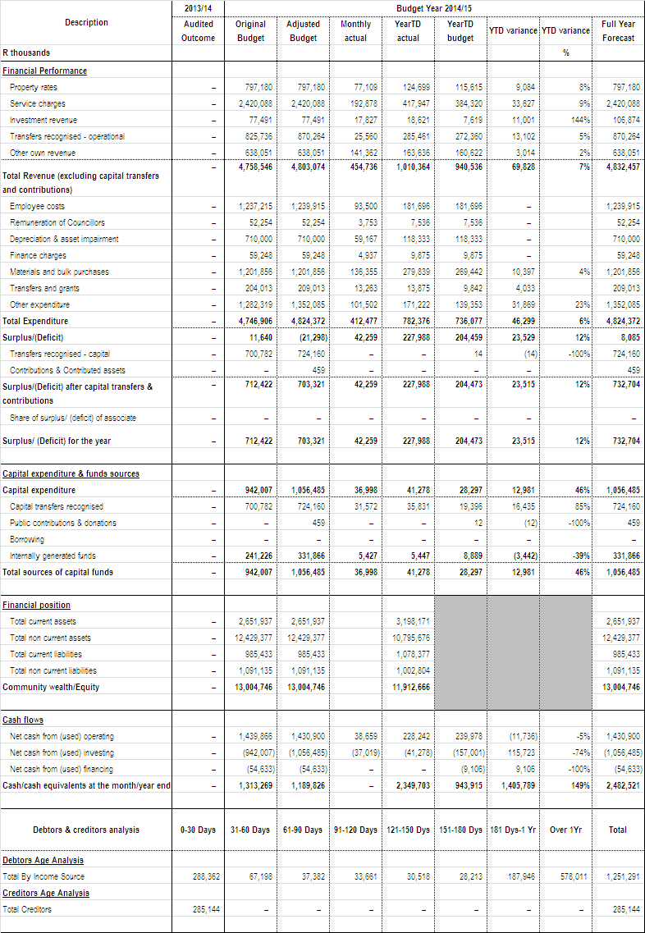

7.2 Monthly Budget Statement – Financial Performance (standard classification)
The table below is an overview of the budgeted financial performance in relation to revenue and expenditure per standard classification.

Table 3:C2: Monthly Budget Statement – Financial Performance (standard classification
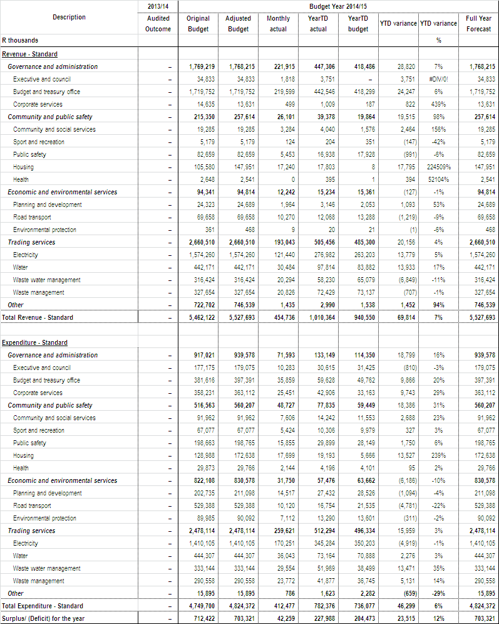

7.3 Monthly Budget Statement – Financial Performance (Revenue and expenditure by municipal vote)

The table below shows budgeted financial performance in relation to the revenue and expenditure by vote as well as the operating surplus or deficit.

Table 4:C3: Monthly Budget Statement – Financial Performance (Revenue and expenditure by municipal vote)

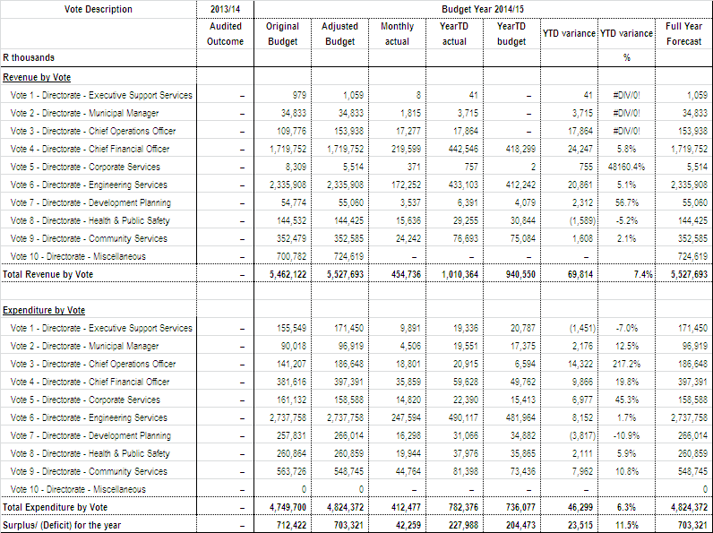

7.4 Monthly Budget Statement – Financial Performance (revenue by source and expenditure by type)

The table below is a view of the budgeted financial performance in relation to the revenue by source and expenditure by type.

Table 5: C4: Monthly Budget Statement – Financial Performance (revenue by source and expenditure by type)

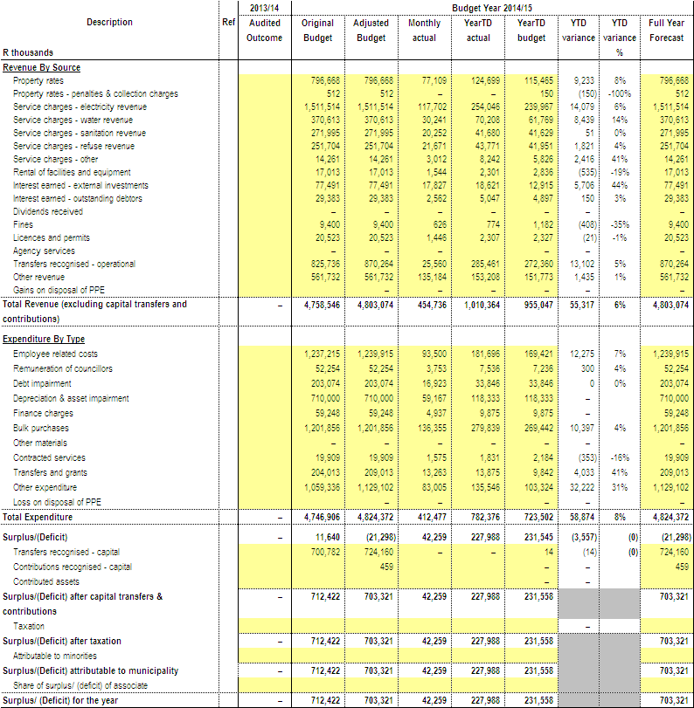

The following tables reflect the percentage variance for revenue and expenditure by by type, reasons for material deviations and the remedial action thereof.

7.5 Material Variance Explanations for Revenue By Source and Expenditure by Type (Refer to Table C4)

Table 6: SC1: Material Variance Explanations for Revenue By Source and Expenditure by Type

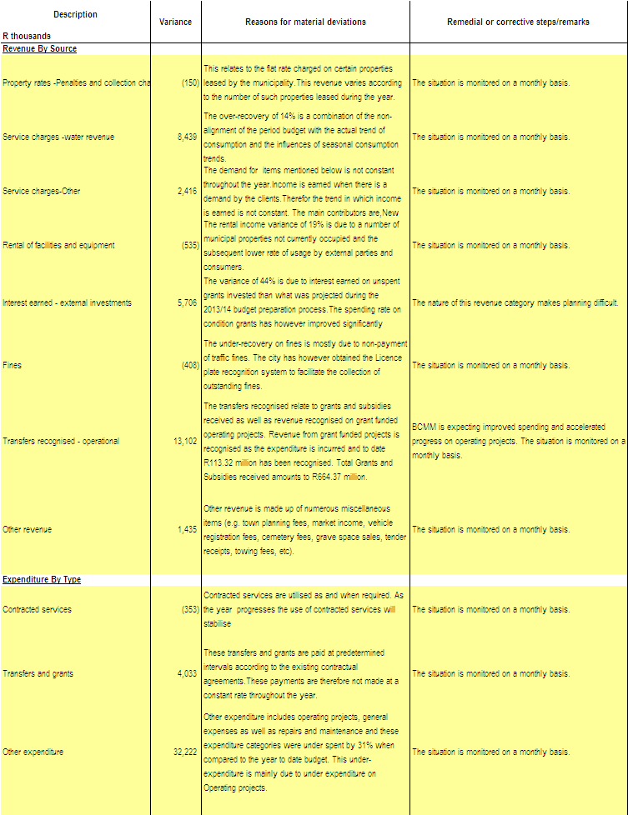

The table below reflects the Metro’s capital programme in relation to capital expenditure by municipal vote, capital expenditure by standard classification and funding sources required to fund the capital budget, including information on capital transfers from National and Provincial departments.

7.6 Table 7: C5: Monthly Budget Statement – Capital Expenditure (municipal vote, standard classification and funding)
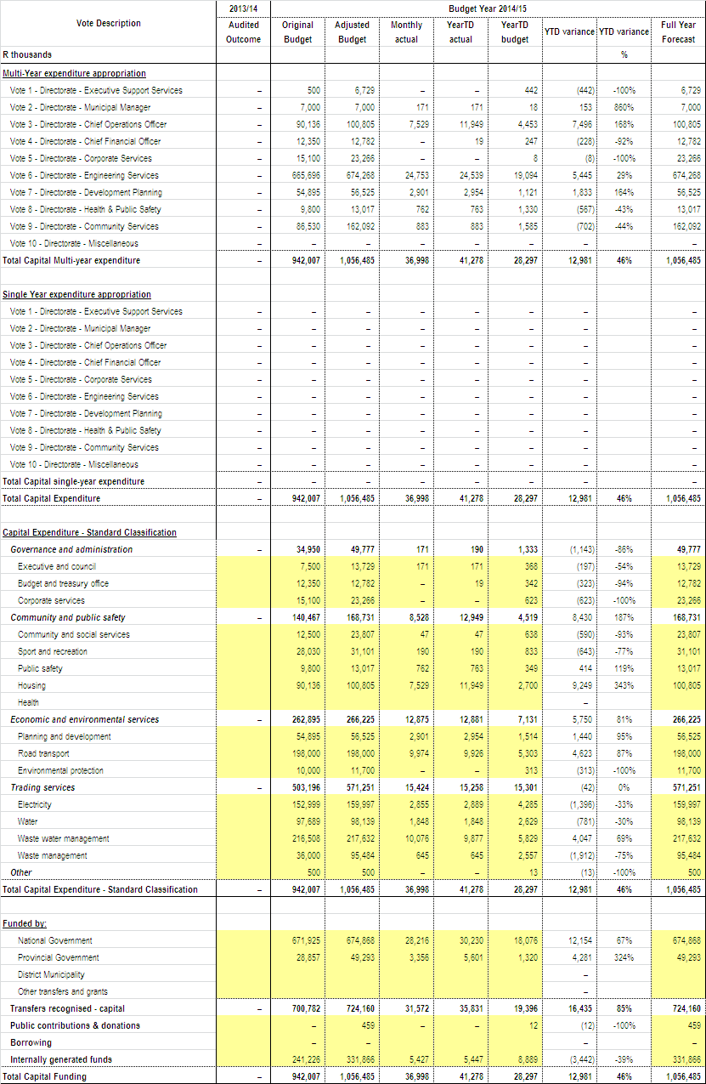

7.7 Monthly Budget Statement – Financial Position
The table below reflects the performance to date in relation to the financial position of the Metro.

Table 8: C6: Monthly Budget Statement – Financial Position
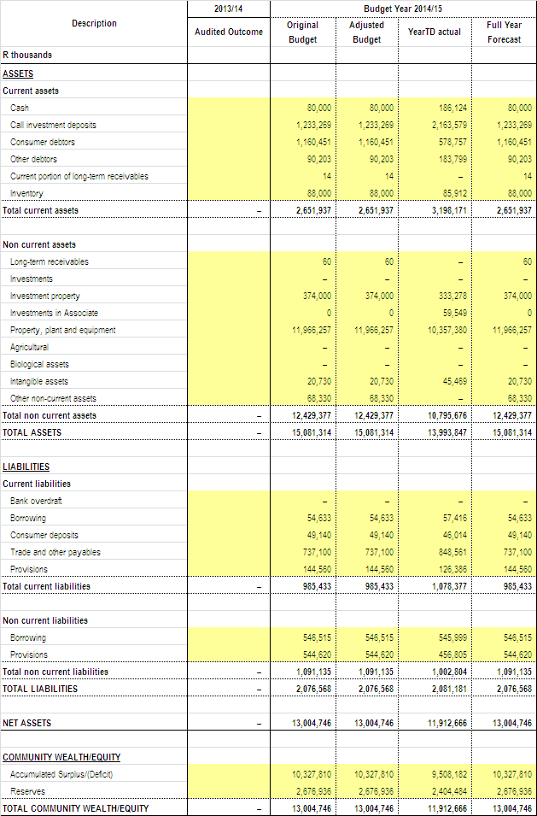

7.8 Monthly Budget Statement – Cash Flow
The Metro’s’ cash flow position and cash/cash equivalent outcome is shown in the table below.

Table 9: C7: Monthly Budget Statement – Cash Flow
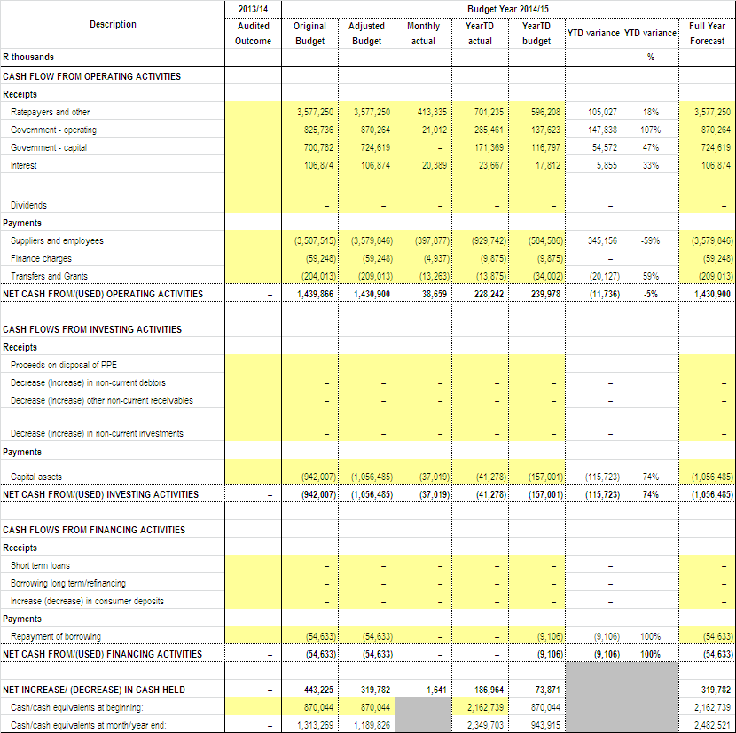

PART 2 -
SUPPORTING DOCUMENTATION

8. DEBTORS’ ANALYSIS
8.1 The debtor analysis provides an age analysis by revenue source and customer category.

Table 10: SC3 Monthly budget statement Aged Debtors
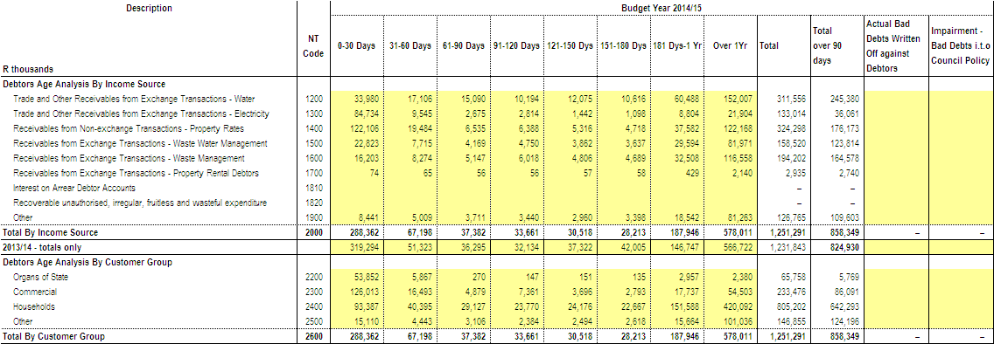

The arrears in respect of 30 days and more, which includes all charges, amounted to R962,929,012 at 31 August 2014 which is an increase of R29,168,308 over the amount of R933,760,704 at 31 July 2014. The primary reason for the increase relates to debtors who fail to settle their current accounts by the due date and therefore the debt ages into 30 days. No collection action can be taken prior to the due date.

Table 11: Debtor’s Age Analysis as at 31 August 2014
AGEING | RATES | SEWERAGE | ELECTRICITY | WATER | REFUSE | SUNDRY  DEBTORS | TOTAL FOR  AUGUST 2014 | TOTAL FOR  AUGUST 2013
30 DAYS | 19,484,178 | 7,714,505 | 9,544,791 | 17,106,143 | 8,273,547 | 5,074,724 | 67,197,888 | 61,974,649
60 DAYS | 6,535,116 | 4,168,550 | 2,675,179 | 15,089,611 | 5,147,234 | 3,766,770 | 37,382,460 | 35,460,247
90 DAYS | 6,388,075 | 4,750,056 | 2,814,110 | 10,194,402 | 6,018,007 | 3,496,505 | 33,661,155 | 33,221,567
120 DAYS  TO 360 DAYS | 47,616,454 | 37,093,233 | 11,342,722 | 83,178,844 | 42,002,201 | 25,443,441 | 246,676,896 | 204,687,499
YEAR 2 | 36,739,264 | 25,859,824 | 7,394,325 | 49,912,407 | 32,974,223 | 23,908,434 | 176,788,477 | 167,226,964
YEAR 3 | 25,188,482 | 15,480,086 | 7,185,258 | 28,676,443 | 20,811,516 | 15,470,387 | 112,812,171 | 87,738,203
YEAR 4 | 16,668,262 | 9,254,411 | 2,364,733 | 17,164,825 | 12,366,400 | 9,684,501 | 67,503,131 | 77,015,675
YEAR 5 | 13,133,391 | 8,038,453 | 2,159,581 | 17,424,024 | 14,374,192 | 9,882,456 | 65,012,097 | 199,612,582
YEAR 5+ | 30,438,922 | 23,338,344 | 2,799,776 | 38,829,203 | 36,031,490 | 24,457,002 | 155,894,738 | 199,612,582
TOTAL | 202,192,144 | 135,697,461 | 48,280,474 | 277,575,902 | 177,998,811 | 121,184,220 | 962,929,012 | 866,937,386

8.2 Additional debtor’s information
8.2.1 Age Analysis per Category

Table 12: Age Analysis per Category Type as at 31 July 2014
CATEGORY TYPE | 30 DAYS | 60 DAYS | 90 DAYS | 120 DAYS+ | Total | % Share
Domestic | 32,473,415 | 20,948,343 | 16,599,550 | 505,504,482 | 575,525,790 | 59.77
Indigent | 7,628,952 | 8,069,542 | 7,048,560 | 112,377,373 | 135,124,427 | 14.03
Business | 16,493,429 | 4,879,327 | 7,361,013 | 78,729,639 | 107,463,408 | 11.16
Government | 5,866,629 | 269,927 | 146,815 | 5,622,497 | 11,905,868 | 1.24
MunicIpal Staff | 265,835 | 104,656 | 118,087 | 622,674 | 1,111,252 | 0.12
Councillors | 26,571 | 4,181 | 3,534 | 18,812 | 53,097 | 0.01
Other | 4,443,056 | 3,106,485 | 2,383,596 | 121,812,032 | 131,745,170 | 13.68
Total | 67,197,888 | 37,382,460 | 33,661,155 | 824,687,509 | 962,929,012 | 100.00

Note*: A stop order deduction is implemented for all municipal staff and councillors in arrears. When new staff join the employ of the municipality in many instances there is services debt, and therefore the arrears will be liquidated over an acceptable period of time, in terms of the Credit Control Policy. The reason why the debt reflects in the 30/60/90 day columns relating to staff and councillors is due to the fact that when the stop orders are receipted the payment is allocated to the oldest ageing category, giving the impression that current is not being paid, which is not the case as an amount is being deducted for current accounts.

8.2.2 Billing, Receipts and Debtors Collection Rate

Table 13: Cumulative Nett Billing, Receipts and Debtors Collection Ratio per month from 2012/13 to 2014/15 financial year

Month | 2012/2013 |  |  | 2013/2014 |  |  | 2014/2015
 | Billing | Receipts | Collection Rate | Billing | Receipts | Collection Rate | Billing | Receipts | Collection Rate
July | 238,333,589 | -155,444,098 | 90.42 | 2,325,509,002 | -2,153,249,916 | 92.59 | 2,602,264,135 | -2,371,903,619 | 91.00
August | 456,862,028 | -318,827,484 | 68.55 | 2,360,722,274 | -2,184,105,932 | 92.52 | 2,568,699,884 | -2,383,877,074 | 93.00
September | 637,913,507 | -509,870,368 | 77.58 | 2,362,100,818 | -2,201,573,537 | 93.20
October | 814,187,990 | -711,819,642 | 87.22 | 2,390,760,330 | -2,214,093,193 | 92.61
November | 1,003,917,047 | -884,987,889 | 89.60 | 2,413,236,105 | -2,237,227,839 | 92.71
December | 1,187,612,559 | -1,046,276,767 | 89.74 | 2,451,423,493 | -2,277,540,737 | 92.91
January | 1,376,713,577 | -1,219,332,883 | 89.58 | 2,473,521,774 | -2,288,389,311 | 92.52
February | 1,571,214,609 | -1,399,676,516 | 90.38 | 2,489,423,294 | -2,286,023,845 | 91.83
March | 1,756,245,816 | -1,575,792,522 | 90.40 | 2,508,588,241 | -2,317,244,720 | 92.37
April | 1,928,740,621 | -1,770,276,496 | 91.95 | 2,533,810,040 | -2,313,671,267 | 91.31
May | 2,136,072,369 | -1,952,779,796 | 93.19 | 2,563,282,383 | -2,324,079,609 | 90.67
June | 2,325,509,002 | -2,134,450,531 | 92.65 | 2,565,798,810 | -2,350,536,518 | 91.61

8.2.3 Government Accounts
The total arrears owed by Government Departments to Buffalo City Metropolitan Municipality as at 31 August 2014 amounted to R11,905,868.

Arrears as at 31 August 2014 R11,905,868
Arrears as at 31 July 2014 R11,238,414
Increase R 667,454

A total payment of R12,055,528.15 was received from Government Departments in August 2014.The breakdown of the arrears per department is indicated in the table hereunder, as at 31 August 2014.Accounts in credit are excluded.

Table 14: Analysis of Government Debt as at 31 August 2014
DEPARTMENT | PROPERTY RATES | SERVICES | ARREARS AS AT  31 AUGUST 2014 | ARREARS AS AT  31 JULY 2014 | DIFFERENCE
National Department Of Public Works | 1,837,105 | 2,004,456 | 3,841,562 | 2,317,544 | 1,524,018
Provincial Department Of Public Works | 1,405,696 | 4,008,820 | 5,414,517 | 4,653,642 | 760,874
Department Of Education |  | 1,170,638 | 1,170,638 | 1,234,660 | (64,023)
Department Of Health |  | 1,151,764 | 1,151,764 | 1,968,971 | (817,208)
Department Of Social Development |  | 38,863 | 38,863 | 147,736 | (108,874)
Department Of Transport |  | - | - | - | -
Department Of Agriculture |  | 147,206 | 147,206 | 747,920 | (600,713)
Department Of Nature Conservation |  | 945 | 945 | 2,870 | (1,925)
Department of Community Development |  | 3,266 | 3,266 | - | 3,266
Sport, Recreation, Arts and Culture |  | 65,335 | 65,335 | 63,930 | 1,405
Unemployment Insurance |  | 5,099 | 5,099 | 1,143 | 3,955
Members Of Provincial Legislature |  | 66,674 | 66,674 | 99,996 | (33,322)
Department of Water Affairs |  | - | - | - | -
TOTAL | 3,242,801 | 8,663,067 | 11,905,868 | 11,238,414 | 667,455

Credit Control action is implemented to recover debt.

9. CREDITORS’ ANALYSIS
9.1 The creditors’ analysis contains an aged analysis by customer type.
Table 15: SC4 Monthly budget Statement Aged Creditors
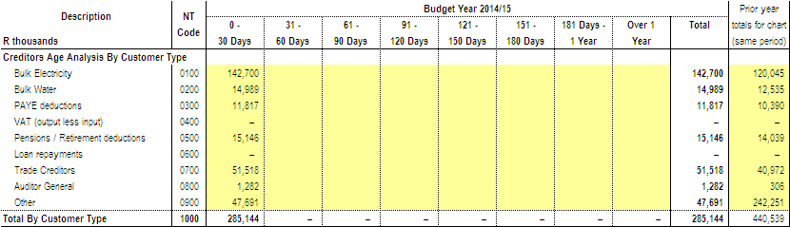

The amounts on this schedule are the actual payments made by BCMM to its creditors in August 2014.

Table 16: 20 Highest Paid Creditors – August 2014
CREDITOR | 90 DAYS | 60 DAYS | 30 DAYS | CURRENT | TOTAL | PAYMENT
MANTELLA TRADING 522 CC |  |  |  | 5,054,754.98 | 5,054,754.98 | 5,054,754.98
SITA ( PTY) LTD |  |  |  | 4,227,895.16 | 4,227,895.16 | 4,227,895.16
KEPU TRADING (PTY) LTD |  |  |  | 4,150,255.31 | 4,150,255.31 | 4,150,255.31
ELECTRICAL MOULDED COMPONENTS |  |  |  | 2,995,991.25 | 2,995,991.25 | 2,995,991.25
LIFETIME CONNECTION MANUFACTURING SUPPLY CC |  |  |  | 2,750,971.81 | 2,750,971.81 | 2,750,971.81
MAKINWA MEDIA MANAGEMENT |  |  |  | 2,672,119.36 | 2,672,119.36 | 2,672,119.36
MASIQHAME TRADING 520 CC |  |  |  | 2,261,339.34 | 2,261,339.34 | 2,261,339.34
2LL2M ENTERPRISE CC |  |  |  | 1,888,532.64 | 1,888,532.64 | 1,888,532.64
EYA BANTU PROFFESSIONAL SERVICES CC |  |  |  | 1,628,524.86 | 1,628,524.86 | 1,628,524.86
C & M FASTENERS CC |  |  |  | 1,374,094.31 | 1,374,094.31 | 1,374,094.31
SCHELTEMA & COMPANY PTY LTD |  |  |  | 1,306,849.34 | 1,306,849.34 | 1,306,849.34
GEMINI MOON TRADING 6 CC |  |  | 1,208,015.82 |  | 1,208,015.82 | 1,208,015.82
MOKO CONSTRUCTION CC |  |  |  | 1,050,412.33 | 1,050,412.33 | 1,050,412.33
HENZEL MAXIFLEX |  |  |  | 942,025.32 | 942,025.32 | 942,025.32
LUGOGWANA COMTECH CC |  |  |  | 938,974.87 | 938,974.87 | 938,974.87
T V R CONSTRUCTION |  |  | 546,530.54 | 391,302.91 | 937,833.45 | 937,833.45
ACTOM MV SWITCHGEAR |  |  |  | 804,488.16 | 804,488.16 | 804,488.16
MVEZO PLANT & CIVILS CC |  |  |  | 791,024.98 | 791,024.98 | 791,024.98
MTIMA PLUMBING SERVICE |  |  |  | 781,643.23 | 781,643.23 | 781,643.23
PLATINUM AFRICA |  |  |  | 748,918.96 | 748,918.96 | 748,918.96
TOTAL | - | - | 1,754,546.36 | 36,760,119.12 | 38,514,665.48 | 38,514,665.48
10. INVESTMENT PORTFOLIO ANALYSIS
10.1 The investment portfolio analysis includes information on the institution where funds are invested, period of investment, type of investment and accrued interest for the month.
Table 17: SC5 Monthly budget Statement – investment portfolio
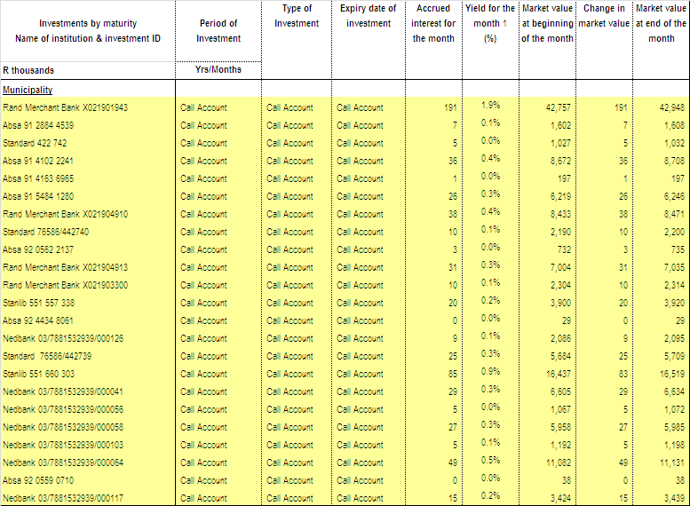
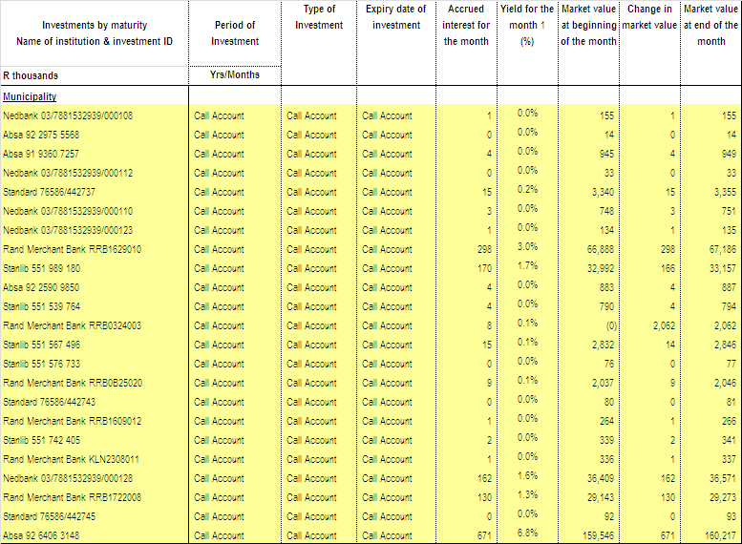
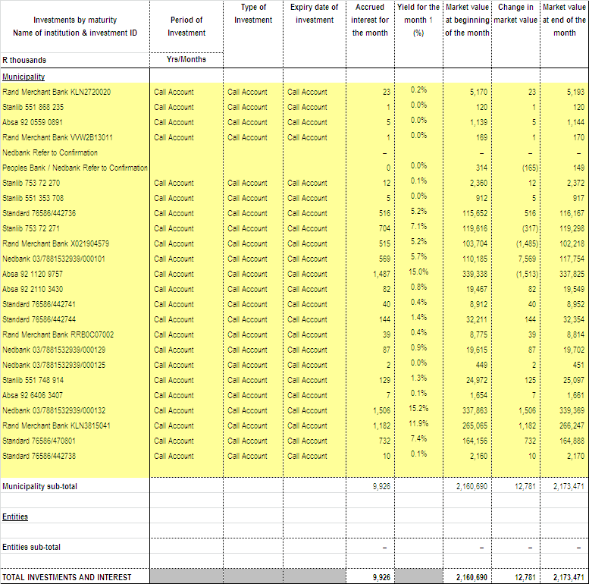
11. ALLOCATION AND GRANT RECEIPTS AND EXPENDITURE
11.1 Transfers and grants expenditure per allocation or grant is provided in the table below.
Table 18: SC7 Monthly budget Statement – transfers and grants expenditure
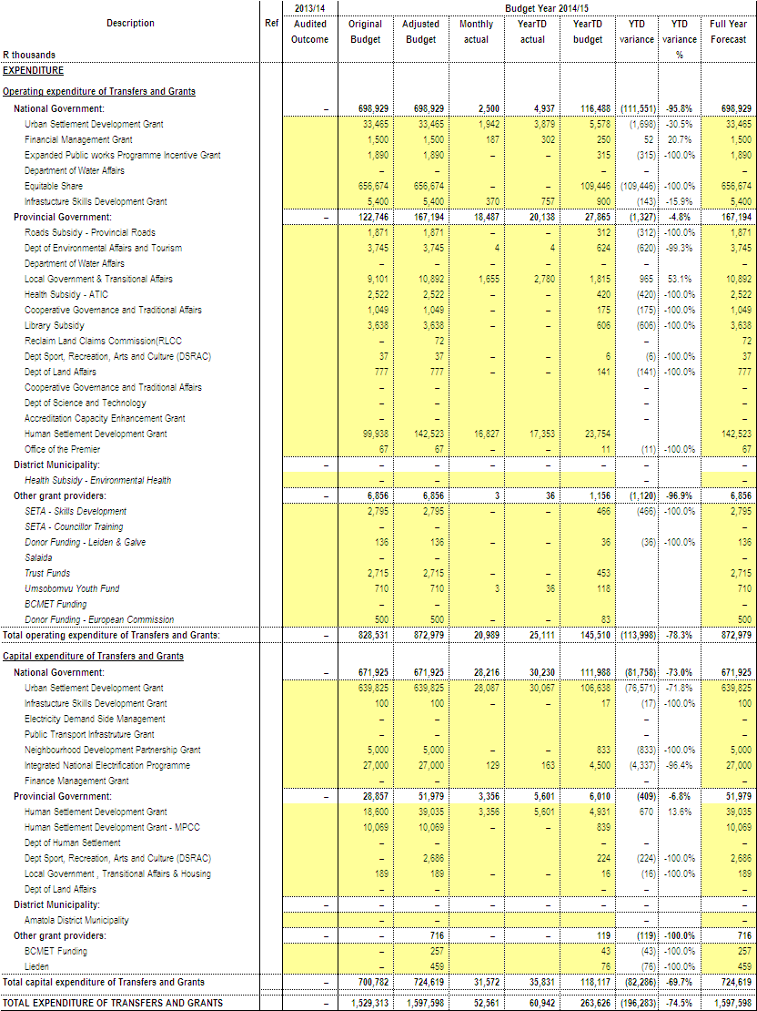
EXPENDITURE ON CONDITIONAL GRANT ALLOCATIONS
The total expenditure inclusive of reclaimed vat on conditional grants DoRA allocation as at 31 August 2014 amounts to R39.22 million which is 5% of the approved budget of R714.18 million.

Table 19 below reflects the year to date expenditure on 2014/15 total conditional grants.

Table 19: Spending per Conditional Grant Funding Allocation
Funding/Grant | 2014/2015 Approved Budget | YTD Expenditure | Variance | % Exp vs. Budget
DoE(Integrated National Electrification Programme) | 27 000 000 | 163 152 | 26 836 848 | 1%
Finance Management Grant | 1 500 000 | 301 660 | 1 198 340 | 20%
Infrastructure Skills Development Grant | 5 500 000 | 759 896 | 4 740 104 | 14%
Urban Settlement Development Grant | 673 289 000 | 37 996 480 | 635 292 520 | 6%
Neighbourhood Development Partnership | 5 000 000 | 0 | 5 000 000 | 0%
Expanded Public Works Programme | 1 890 000 | 0 | 1 890 000 | 0%
TOTAL | 714 179 000 | 39 221 189 | 674 957 811 | 5%

- INTERGRATED NATIONAL ELECTRIFICATION PROGRAMME (INEP)
Reasons for the Low Expenditure
The funds are to be used for Bulk Construction Zoo 40Mva Substation & Electrification, Installation of MV and LV network within RDP areas and Services to 1163 dwellings.
Bulk Construction Project progress is in terms of the Project program. Completion date is 30 June 2015 (multiyear project) and electrification has commenced.

- FINANCE MANAGEMENT GRANT (FMG)
Reasons for the Low Expenditure
The funding will be utilised as follows: Implementation of Standard Chart of Accounts (SCOA), training of municipal officials in financial management towards attaining the minimum competencies and Interns remuneration. Expenditure is ongoing and therefore progressing well.
- INFRASTRUCTURE SKILLS DEVELOPMENT GRANT (ISDG)
Reasons for the Low Expenditure
The project is ongoing and the expenditure is according to the monthly cashflows. Expenditure will improve as the financial year progresses

- URBAN SETTLEMENT DEVELOPMENT GRANT (USDG)

HOUSING
Reasons for the Low Expenditure
The projects that were planned to push the expenditure were blocked at procurement stages that has got long turnaround times and were due to be finalised within the first two quarters of the last financial year (2013/14), and were only finalised in this financial year mid July 2014 and the appointment letters were sent to service providers at the end of July 2014. These projects are Mdantsane Zone 18 CC, Mdantsane Cluster 2, Cluster 3, and Fynboss Cluster projects. The Department is busy with contractual matters and anticipate to hand over sites by the end of August 2014. The under expenditure will be recovered as the project progresses within this financial year (2014/2015).
Corrective Measures to improve expenditure
Contractual matters will be finished by the end of August 2014 and immediately after that sites will be handed to contractors with close monitoring their performance trying to recover under expenditure.
The contractor for Mdantsane Zone 18CC, Mdantsane Cluster 2, Fynboss 1& 2 and Ndancama have been appointed in August 2014. The Department is busy finalising the Contractual Agreements between BCMM and the Contractors.
Reasons for the Low Expenditure
The USDG budget for sanitation capital projects is R176.51 million and R4.34 million has been spent (2.5%). The Department has ongoing multi-year projects i.e. Reeston Waste-Water Treatment Works, Rural Sanitation and Bufferstrip Phase 3.

The contractor for West Bank Wastewater Infrastructure was cancelled, due to the fact that the contractor did not have access to the site due to land issues i.e. Land admin not able to pay for the required servitude in time.

Corrective Measures to improve expenditure
Annual contractor is currently on site to complete the works for the Wastewater Infrastructure project and the tender document is being prepared to re- tender for the Water Infrastructure project.

DEVELOPMENT PLANNING & ECONOMIC DEVELOPMENT
Reasons for the Low Expenditure
Transport Planning and Operations
Current expenditure is in line with planned expenditure for August 2014. Expenditure is expected to ramp up as projects progress from the commencement stage.

Land Surveying
The service provider has completed the surveys for Fynbos I, Fynbos II and Ndancama for the provisional phase. Due to environmental challenges affecting the layout plan, and the fact that the shacks and bushes have not been removed, the project has come to a standstill. DEDEAT has given approval to go ahead with 80% of the Fynbos 1 and Fynbos II projects. This means that engineers can now finalize their engineering designs for the approved parts. The surveyor has amended the General Plans and is waiting for the TRA’s to be constructed so that beaconing can commence.

Corrective Measures to improve expenditure
Land Surveying
The placing of internal beacons can only be done once the shacks and bush have been removed. As soon as the contractor moves on site, and clears the bushes and the shacks, the land Surveyor can complete his work. The tender for the construction of the civil services and housing has been advertised. This tender includes the construction of a TRA which will be used to resettle the beneficiaries. Once the contractor is appointed, the beaconing can commence.The contract has been awarded and the contractor will move onto the site soon.

HEALTH AND PUBLIC SAFETY
Reasons for the Low Expenditure

KWT Traffic building -Architectural Department met with Professional Team on 8th August 2014 to discuss details of the contract and date of commencement. They were requested to liaise with BCMM department with regards to the requirements of structure in terms of a number of offices, ablutions etc.

Corrective Measures to improve expenditure

Public Safety to provided Architectural Department with requirements of structure in terms of a number of offices, ablutions etc, in a meeting scheduled for the beginning of September 2014.

COMMUNITY SERVICES
Reasons for the Low Expenditure
Expenditure is not as high as anticipated, due to a change in approach to project implementation in the later part of 2013 by the Acting Director of Community Services which resulted in the scope of work, and procurement methods changing.

Corrective Measures to improve expenditure
The use of informal tenders and annual contracts will assist in improving expenditure.

- NEIGHBOURHOOD DEVELOPMENT PARTNERSHIP GRANT (NDPG)
Reasons for the Low Expenditure
Annual Contract 26 to be utilized, currently awaiting updated quotations from the contractors for the upgrade of Sandile Road. National Treasury will provide a go ahead for project implementation.

Corrective Measures to improve expenditure
Instruction issued to Roads Department to provide new quotations.

- EXPANDED PUBLIC WORKS PROGRAMME (EPWP)
Reasons for the Low Expenditure
The municipality has an allocation of R 1.89 million for the 2014/15 financial year from the National Department of Public Works.

Corrective Measures to improve expenditure
A Business Plan has been approved for the following projects: Operations and Maintenance of public ablution facilities (R 567 000); Maintenance of Eco Parks (R 378 000) & Maintenance of roads within BCMM clusters (R 945 000). These Projects are ongoing, and as the year progresses the expenditure will stabilize.

12. COUNCILLOR AND EMPLOYEE BENEFITS
12.1 Monthly Budget Statement – Councilor and Staff Benefits
Table 20: SC8 Monthly Budget Statement – Councilor and Staff Benefits

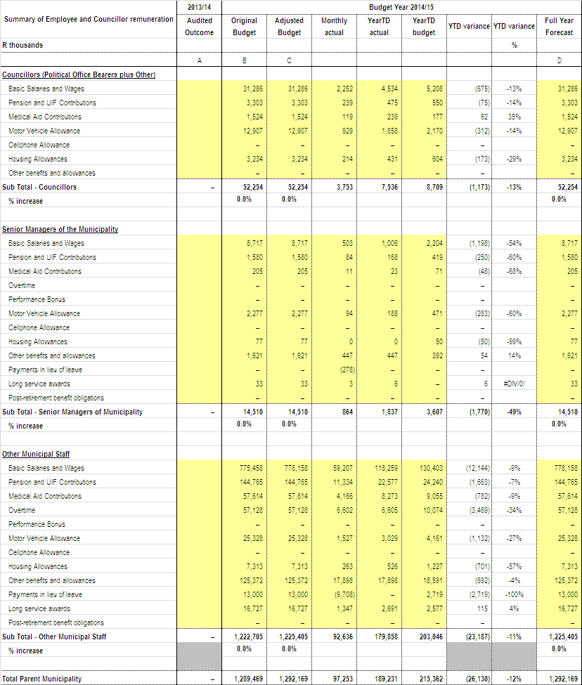

Table 21: ANALYSIS OF OVERTIME

 | JUNE  2014 | JULY  2014 | AUGUST  2014
Directorate – Executive Support Services | 347 273 | 398 833 | 310 090
Directorate – Municipal Manager | 52 923 | 60 839 | 53 060
Directorate – Chief Operations Officer | - | 32 090 | 16 729
Directorate – Chief Financial Officer | 124 117 | 226 589 | 19 985
Directorate – Corporate Services | 54 719 | 63 359 | 41 543
Directorate – Engineering Services | 1 398 220 | 2 743 858 | 1 961 599
Directorate – Development Planning | 29 929 | 75 972 | 26 701
Directorate – Health & Public Safety | 1 471 335 | 1 617 847 | 1 285 913
Directorate – Community Services | 3 380 515 | 2 630 073 | 2 886 118
TOTAL | 6 859 031 | 7 849 459 | 6 601 737

The total overtime payment for the months of June 2014, July 2014 and
August 2014 is reflected above. There was an increase in the total payment of overtime between June 2014 and July 2014 of R990 428 and a decrease in the total payment of overtime between July 2014 and August 2014 of R1 247 722.

Table 22: OVERTIME PER COST CENTRE: JUNE 2014 – AUGUST 2014

 | OVERTIME PER COST CENTRE
 |  | June 2014 Amount | July 2014 Amount | August 2014 Amount
 | Directorate -Executive Support Services
105 005 | Office of The Director of Executive Support | 273 058.53 | 326 099.12 | 264 615.46
105 020 | Public Participation & Ward Committees | 8 149.41 | 4 454.69 | 4 917.22
105 030 | Special Programmes | 3 315.73 | - | 239.13
120 010 | Public Relations & International Events | 62 749.66 | 68 279.44 | 40 317.76
 |  | 347 273.33 | 398 833.25 | 310 089.57
 | Directorate - Municipal Manager
205 005 | Office of The Municipal Manager & Support Services | 41 143.87 | 33 895.47 | 41 290.34
215 005 | Internal Audit | - | 14 622.32 | -
225 010 | Municipal Public Accounts Committee | 11 779.38 | 12 321.10 | 11 769.18
 |  | 52 923.25 | 60 838.89 | 53 059.52
 |  | June 2014 Amount | July 2014 Amount | August 2014 Amount
 | Directorate - Chief Operations Officer
250 005 | Office of the Chief Operations Officer | - | 32 089.80 | 16 728.52
 |  | - | 32 089.80 | 16 728.52
 | Directorate - Chief Financial Officer
305 005 | Office of The Director of Finance | - | 3 378.02 | -
315 005 | Budget Office | 1 844.82 | - | 8 219.84
320 010 | Supply Chain Management | 1 569.36 | 91 769.17 | -68 277.65
320 015 | Expenditure Office | - | 26 743.86 | 7 760.99
320 020 | Salary Office | - | - | 2 254.11
330 010 | Consolidated Billing & Miscellaneous Revenue Office | 105 936.81 | 33 984.17 | 422.59
330 015 | Debtors Management Office | - | 54 754.28 | 56 599.88
330 020 | Customer Care Office | 14 765.95 | 15 959.08 | 13 004.87
 |  | 124 116.94 | 226 588.58 | 19 984.63
 | Directorate - Corporate Services
415 005 | Administrative & Council Support | 492.62 | 18 435.77 | 888.56
415 010 | Auxilliary & Telecommunication Services | 27 969.48 | 18 470.33 | 18 444.87
415 025 | Management Information Services | 11 185.03 | 10 394.75 | 7 326.08
420 005 | H.R. Administration | 11 102.13 | 4 537.74 | 14 883.53
420 010 | Occupational Risk Management | 3 970.05 | 10 208.70 | -
420 020 | Organisational Development | - | 1 311.42 | -
 |  | 54 719.31 | 63 358.71 | 41 543.04
 | Directorate - Engineering Services
505 005 | Office of The Director of Engineering Services - Admin | 2 398.44 | 1 526.28 | 1 430.64
505 010 | City Engineering Building | 1 435.20 | - | 3 629.15
505 015 | Chiselhurst, Beacon Bay & Kwt Depot | 17 350.56 | 13 801.14 | 15 260.16
510 005 | Scientific Services | - | - | 1 752.44
515 006 | Night Soil Removal - Coastal | 55 859.48 | 61 908.68 | 42 216.59
515 007 | Night Soil Removal - Central | 1 018.73 | 3 046.20 | 2 381.12
515 026 | Sewerage Treatment - Coastal | 57 190.15 | 33 342.27 | 48 043.33
515 027 | Sewerage Treatment - Central | 28 060.43 | 36 542.18 | 34 712.24
515 028 | Sewerage Treatment - Inland | 100 661.68 | 84 952.18 | 46 989.34
515 031 | Sewerage Reticulation - Coastal | 165 356.91 | 157 000.77 | 181 798.09
515 032 | Sewerage Reticulation - Central | 86 423.93 | 101 313.89 | 93 038.18
515 033 | Sewerage Reticulation - Inland | 75 762.95 | 120 292.20 | 79 650.75
520 005 | Water Administration | - | 15 928.67 | 2 436.81
520 011 | Maden Dam | 9 230.22 | 10 623.60 | 13 012.50
520 012 | Bridle Drift Dam | - | 7 372.64 | -
520 015 | Bulk Pumping Stations | - | 40 377.72 | 10 119.77
520 021 | Umzonyana Water Treatment Works | - | 121 861.16 | 41 304.48
520 023 | KWT Water Treatment Works | 102 926.37 | 101 211.87 | 116 771.24
520 024 | Mdantsane Bulk Pumping | - | 69 556.58 | -
520 025 | Water Ops & Maint. - Inland | 46 807.08 | 293 506.65 | 247 432.11
520 026 | Water Ops & Maint. - Midland | - | 391 302.97 | 185 240.46
 |  | June 2014 Amount | July 2014 Amount | August 2014 Amount
520 030 | Water Ops & Maint. - Coastal | 19 417.30 | 414 039.06 | 234 274.33
525 010 | Roads Administration | 4 747.65 | 4 604.81 | 3 910.94
525 025 | Roads & Stormwater Drainage | 66 602.30 | 21 797.96 | 23 891.20
525 040 | Project Management Unit | - | 415.00 | -
530 005 | Mechanical Workshop - Westbank | - | 299.63 | -
530 010 | Fleet Management - Westbank | - | 1 681.40 | 1 539.00
530 015 | Mechanical Workshop - Braelyn | 33 172.05 | 28 801.78 | 19 481.97
535 005 | Electricity Administration | 1 856.30 | 1 902.32 | 2 146.28
535 010 | Electricity Distribution Supervisory Staff | 447 438.52 | 533 629.35 | 455 674.22
535 025 | Electricity Planning & Design | 509.37 | 419.48 | 655.35
535 040 | Revenue Protection | 73 994.27 | 70 799.68 | 52 806.19
 |  | 1 398 219.89 | 2 743 858.12 | 1 961 598.88
 | Directorate - Development Planning
615 070 | City Planning | - | 4 958.73 | -5 012.70
615 095 | Building Maintenance - Coastal / Central | - | 18 087.38 | -
620 015 | Traffic Signal Maintenance | 11 628.28 | 6 509.28 | 7 046.46
625 005 | Buffalo City Bus Services | 18 300.30 | 11 068.53 | 10 661.30
635 005 | Local Economic Development | - | 1 127.78 | -
635 010 | Market | - | 34 220.27 | 14 006.42
 |  | 29 928.58 | 75 971.97 | 26 701.48
 | Directorate - Health & Public Safety
710 030 | Environmental Health | 1 071.48 | - | -
710 040 | Pollution Control | 636.84 | 1 273.68 | -
725 005 | Public Safety Administration | - | - | 4 613.22
725 010 | Fire & Rescue Services | 345 107.24 | 258 707.76 | 216 957.04
725 015 | Law Enforcement Services | 741 814.02 | 884 252.84 | 780 625.36
725 020 | Traffic Administration | 73 090.61 | 96 398.09 | 42 702.91
725 025 | Traffic Control | 249 559.34 | 316 343.80 | 198 001.59
725 030 | Criminal Process | 14 692.13 | 7 905.69 | 3 502.50
725 035 | Vehicle Test Station / Examination | 4 258.86 | 8 292.18 | 4 974.07
725 036 | Vehicle Registration | 5 941.30 | 14 815.08 | -
725 040 | Drivers License Testing | 835.35 | 1 160.67 | -
725 045 | Traffic Technical Services | 2 398.39 | 223.49 | 7 053.62
725 050 | Parking Areas / Meters | 26 951.87 | 24 405.30 | 25 217.54
725 055 | Disaster Management | 4 673.28 | 4 068.17 | 2 265.32
730 005 | Dog Tax Office | 303.90 | - | -
 |  | 1 471 334.61 | 1 617 846.75 | 1 285 913.17
 | Directorate - Community Services
750 005 | Office of The Director of Community Services | 59 085.10 | 47 989.35 | 43 774.68
750 010 | Cleansing Administration Support | 1 371.96 | 3 048.80 | 1 666.80
755 010 | Environmental Services | 592 293.70 | 342 265.65 | 370 253.36
755 015 | Environmental Conservation | 160 278.72 | 119 670.29 | 142 994.62
755 020 | Environmental Workshop | 6 197.96 | 10 030.57 | 1 219.61
755 025 | Interments | 342 751.81 | 255 070.08 | 315 805.58
   | JUNE  2014 | JULY  2014 | AUGUST 2014
   | JUNE  2014 | JULY  2014 | AUGUST 2014
  June 2014  Amount | JUNE  2014 | JULY  2014 | AUGUST 2014
  July 2014  Amount | JUNE  2014 | JULY  2014 | AUGUST 2014
  August 2014  Amount | JUNE  2014 | JULY  2014 | AUGUST 2014
760 005 | Arts & Cultural Services Admin | 37 525.02 | 28 249.46 | 33 080.71
760 010 | Libraries | 28 570.97 | 13 492.35 | 11 554.46
760 015 | Art Gallery | 3 902.92 | 3 580.38 | 497.28
760 025 | Halls | 159 921.28 | 136 485.71 | 130 391.22
765 005 | Amenities Administration Support | 81 006.09 | 32 285.26 | 19 530.99
765 010 | Sportsfields | 113 683.01 | 97 075.31 | 78 294.93
765 015 | Swimming Pools | 149 532.56 | 90 713.52 | 5 943.66
765 020 | Aquarium | 40 112.17 | 38 799.66 | 26 412.12
765 025 | Zoo | 59 927.64 | 60 479.90 | 53 437.40
765 030 | Beaches | 170 993.03 | 148 644.32 | 148 622.90
765 035 | Resorts | 84 165.36 | 62 198.17 | 48 470.77
770 005 | Cleansing Administration Support | 49 828.01 | 47 621.96 | 53 022.47
770 010 | Refuse Removal | 568 991.60 | 475 772.41 | 625 574.79
770 015 | Waste Disposal Sites | 17 840.09 | 16 454.45 | 14 856.59
770 020 | Street Sweeping | 522 269.05 | 474 324.63 | 628 238.21
770 025 | Public Conveniences | 80 761.80 | 82 960.44 | 100 317.58
770 030 | E.L Regional Waste Disposal Site & Transfer Station | 49 505.20 | 42 860.47 | 32 157.52
 |  | 3 380 515.05 | 2 630 073.14 | 2 886 118.25
 | TOTAL OVERTIME | 6 859 030.96 | 7 849 459.21 | 6 601 737.06

Table 23: Analysis of Standby & Shift
 | JUNE  2014 | JULY  2014 | AUGUST 2014
Directorate – Executive Support Services | 11 617 | 11 535 | 12 226
Directorate – Municipal Manager | 6 030 | 6 249 | 6 611
Directorate – Chief Financial Officer | 4 929 | 4 865 | 5 721
Directorate – Corporate Services | 13 477 | 13 685 | 13 524
Directorate – Engineering Services | 314 767 | 562 595 | 458 068
Directorate – Development Planning | 14 858 | 10 221 | 9 168
Directorate – Health & Public Safety | 165 626 | 173 280 | 171 775
Directorate – Community Services | 172 143 | 156 382 | 230 207
TOTAL | 703 449 | 938 812 | 907 301

The total standby and shift payment for the months of June 2014, July 2014 and
August 2014 is reflected above. There was an increase in the total payment between June 2014 and July 2014 of R235 363 and a decrease in the total payment between July 2014 and
August 2014 of R31 511.

12.2 COST OF TEMPORARY STAFF

Table 24: Analysis of Temporary Staff

 | JUNE  2014 | JULY  2014 | AUGUST 2014
Directorate – Executive Support Services | 1 006 680 | 958 478 | 1 096 557
Directorate – Municipal Manager | 98 064 | 145 752 | 128 754
Directorate – Chief Operations Officer | 331 454 | 421 003 | 403 131
Directorate – Chief Financial Officer | 1 568 163 | 1 469 505 | 1 219 352
Directorate – Corporate Services | 929 055 | 777 042 | 847 704
Directorate – Engineering Services | 299 950 | 269 208 | 291 042
Directorate – Development Planning | 201 864 | 225 709 | 172 174
Directorate – Health & Public Safety | 3 096 534 | 3 713 047 | 3 634 902
Directorate – Community Services | 4 107 867 | 3 633 175 | 3 651 431
TOTAL | 11 639 631 | 11 612 920 | 11 445 048

The total payment of Temporary Staff for the months of June 2014, July 2014 and
August 2014 is reflected above. There was a decrease in the total payment between June 2014 and July 2014 of R26 712 and a decrease in the total payment between July 2014 and
August 2014 of R167 871.

12.3 COUNCILLORS COSTS
Table 25: Councillors Costs

 | AUGUST  2014 | YTD  EXPEN | YTD  BUDGET | VARIANCE | ANNUAL BUDGET
Mayoral Allowance | 56 078 | 112 156 | 124 066 | 11 910 | 744 398
Deputy Mayoral  Allowance | 44 862 | 89 725 | 99 253 | 9 528 | 595 518
Mayoral Committee Allowance | 378 527 | 757 053 | 930 497 | 173 444 | 5 582 983
Speakers Allowance | 44 862 | 89 725 | 98 845 | 9 120 | 593 067
Councillors Allowance | 1 727 202 | 3 484 936 | 3 961 658 | 476 722 | 23 769 946
Cllr Housing Subsidy | 213 825 | 430 594 | 538 988 | 108 394 | 3 233 928
Cllr Medical Aid | 119 452 | 238 904 | 253 980 | 15 076 | 1 523 877
Cllr Pension Scheme | 238 893 | 474 841 | 520 799 | 45 958 | 3 124 793
Cllr Travel Allowance | 928 852 | 1 857 704 | 2 151 220 | 293 516 | 12 907 321
Cllr U.I.F | - | - | 29 744 | 29 744 | 178 464
TOTAL | 3 752 553 | 7 535 638 | 8 709 049 | 1 173 411 | 52 254 295

The Annual Budget of R52 254 295 prorated per month gives a Year to Date Budget for the month of August 2014 of R8 709 049. The Year to Date Budget less the Year to Date Expenditure of R7 535 638 leaves a Variance of R1 173 411.

13. MUNICIPALITY FINANCIAL PERFORMANCE

13.1 Statement of Financial Performance

The Statement of Financial Performance presented below, compares the expenditure and revenue on accrual basis against budget for the period ending 31 August 2014.
Table 26: Statement of Financial Performance for the period ending 31 August 2014
Description | 2013/14 | Budget Year 2014/15
Description | Audited Outcome | Original Budget | Adjusted Budget | Monthly actual | YearTD actual | YearTD budget | YTD variance | YTD variance | Full Year Forecast
R thousands |  |  |  |  |  |  |  | %
Revenue By Source
Property rates |  | 796,668 | 796,668 | 77,109 | 124,699 | 115,465 | 9,233 | 8% | 796,668
Property rates - penalties & collection charges |  | 512 | 512 | – | – | 150 | (150) | -100% | 512
Service charges - electricity revenue |  | 1,511,514 | 1,511,514 | 117,702 | 254,046 | 239,967 | 14,079 | 6% | 1,511,514
Service charges - water revenue |  | 370,613 | 370,613 | 30,241 | 70,208 | 61,769 | 8,439 | 14% | 370,613
Service charges - sanitation revenue |  | 271,995 | 271,995 | 20,252 | 41,680 | 41,629 | 51 | 0% | 271,995
Service charges - refuse revenue |  | 251,704 | 251,704 | 21,671 | 43,771 | 41,951 | 1,821 | 4% | 251,704
Service charges - other |  | 14,261 | 14,261 | 3,012 | 8,242 | 5,826 | 2,416 | 41% | 14,261
Rental of facilities and equipment |  | 17,013 | 17,013 | 1,544 | 2,301 | 2,836 | (535) | -19% | 17,013
Interest earned - external investments |  | 77,491 | 77,491 | 17,827 | 18,621 | 12,915 | 5,706 | 44% | 77,491
Interest earned - outstanding debtors |  | 29,383 | 29,383 | 2,562 | 5,047 | 4,897 | 150 | 3% | 29,383
Dividends received |  | – | – | – | – | – | – |  | –
Fines |  | 9,400 | 9,400 | 626 | 774 | 1,182 | (408) | -35% | 9,400
Licences and permits |  | 20,523 | 20,523 | 1,446 | 2,307 | 2,327 | (21) | -1% | 20,523
Agency services |  | – | – | – |  | – | – |  | –
Transfers recognised - operational |  | 825,736 | 870,264 | 25,560 | 285,461 | 272,360 | 13,102 | 5% | 870,264
Other revenue |  | 561,732 | 561,732 | 135,184 | 153,208 | 151,773 | 1,435 | 1% | 561,732
Gains on disposal of PPE |  |  | – | – | – | – | – |  | –
Total Revenue (excluding capital transfers and contributions) | – | 4,758,546 | 4,803,074 | 454,736 | 1,010,364 | 955,047 | 55,317 | 6% | 4,803,074
Expenditure By Type
Employee related costs |  | 1,237,215 | 1,239,915 | 93,500 | 181,696 | 169,421 | 12,275 | 7% | 1,239,915
Remuneration of councillors |  | 52,254 | 52,254 | 3,753 | 7,536 | 7,236 | 300 | 4% | 52,254
Debt impairment |  | 203,074 | 203,074 | 16,923 | 33,846 | 33,846 | 0 | 0% | 203,074
Depreciation & asset impairment |  | 710,000 | 710,000 | 59,167 | 118,333 | 118,333 | – |  | 710,000
Finance charges |  | 59,248 | 59,248 | 4,937 | 9,875 | 9,875 | – |  | 59,248
Bulk purchases |  | 1,201,856 | 1,201,856 | 136,355 | 279,839 | 269,442 | 10,397 | 4% | 1,201,856
Other materials |  | – | – | – | – | – | – |  | –
Contracted services |  | 19,909 | 19,909 | 1,575 | 1,831 | 2,184 | (353) | -16% | 19,909
Transfers and grants |  | 204,013 | 209,013 | 13,263 | 13,875 | 9,842 | 4,033 | 41% | 209,013
Other expenditure |  | 1,059,336 | 1,129,102 | 83,005 | 135,546 | 103,324 | 32,222 | 31% | 1,129,102
Loss on disposal of PPE |  |  | – | – |  | – | – |  | –
Total Expenditure | – | 4,746,906 | 4,824,372 | 412,477 | 782,376 | 723,502 | 58,874 | 8% | 4,824,372
Surplus/(Deficit) | – | 11,640 | (21,298) | 42,259 | 227,988 | 231,545 | (3,557) | (0) | (21,298)
Transfers recognised - capital |  | 700,782 | 724,160 | – | – | 14 | (14) | (0) | 724,160
Contributions recognised - capital |  |  | 459 |  |  | – | – |  | 459
Contributed assets |  |  |  |  |  | – | –
Surplus/(Deficit) after capital transfers & contributions | – | 712,422 | 703,321 | 42,259 | 227,988 | 231,558 |  |  | 703,321
Taxation |  |  |  |  |  |  | –
Surplus/(Deficit) after taxation | – | 712,422 | 703,321 | 42,259 | 227,988 | 231,558 |  |  | 703,321
Attributable to minorities
Surplus/(Deficit) attributable to municipality | – | 712,422 | 703,321 | 42,259 | 227,988 | 231,558 |  |  | 703,321
Share of surplus/ (deficit) of associate
Surplus/ (Deficit) for the year | – | 712,422 | 703,321 | 42,259 | 227,988 | 231,558 |  |  | 703,321

Notes to the Statement of Financial Performance for the Period Ending 31 August 2014

- Property rates – Penalties and collection charges
This relates to the flat rate charged on certain properties leased by the municipality.This revenue varies according to the number of such properties leased during the year.

- Service charges-Water revenue
The over-recovery of 14% is a combination of the non-alignment of the period budget with the actual trend of consumption and the influences of seasonal consumption trends.

- Service charges –Other
The demand for items mentioned below is not constant throughout the year.Income is earned when there is a demand by the clients.Therefor the trend in which income is earned is not constant.
The main contributors are:
- New connections – sewerage
- Availability charges
- Admission fees
The situation is monitored on a monthly basis.

- Rental of facilities and equipment
The rental income variance of 19% is due to a number of municipal properties not currently occupied and the subsequent lower rate of usage by external parties and consumers.

- Interest earned –External investments
The variance of 44% is due to interest earned on unspent grants invested than
what was projected during the 2013/14 budget preparation process.The
spending rate on condition grants has however improved significantly

- Fines
The under-recovery on fines is mostly due to non-payment of traffic fines. The city has however obtained the Licence plate recognition system to facilitate the collection of outstanding fines.
- Transfers Recognised – Operational
The transfers recognised relate to grants and subsidies received as well as revenue recognised on grant funded operating projects. Revenue from grant funded projects is recognised as the expenditure is incurred and to date R25.13 million has been recognised. Total Grants and Subsidies received amounts to R260 million. BCMM is expecting improved spending and accelerated progress on operating projects.

- Other Revenue
Other revenue is made up of numerous miscellaneous items (e.g. town planning fees, market income, vehicle registration fees, cemetery fees, grave space sales, tender receipts, towing fees, etc.).

- Contracted Services
Contracted services are utilised as and when required. As the year
progresses the use of contracted services will stabilise.

- Transfers and grants
These transfers and grants are paid at predetermined intervals according to the
existing contractual agreements

- Other expenditure
Other expenditure includes operating projects, general expenses as well as
repairs and maintenance and these expenditure categories were under spent by
31% when compared to the year to date budget.

This under expenditure is mainly due to under expenditure on Operating projects.

- Repairs and Maintenance
Table 27 below reflects that as at 31 August 2014, the repairs and maintenance expenditure is 6% of the approved budget of R332.25 million (2013/14: 8%). Refer to Annexure B: SC13c (repairs and maintenance by asset class).

Table 27: Repairs and Maintenance per Directorate
 | 2014/2015 | 2014/2015 |  | 2014/2015
Directorate | Annual | Annual | 2014/2015 | % of
 | Budget | Expenditure | Variance | Budget
 | R | R | R | %
Directorate of Executive Support | 2,645,438 | 19,866 | 2,625,572 | 1%
Directorate of The Municipal Manager | 72,820 | 0 | 72,820 | 0%
Directorate of Chief Operations Officer | 83,651 | 14,032 | 69,619 | 17%
Directorate of Finance | 2,699,709 | 194,082 | 2,505,627 | 7%
Directorate of Corporate Services | 5,462,300 | 496,484 | 4,965,816 | 9%
Directorate of Engineering Services | 260,749,491 | 17,157,270 | 243,592,221 | 7%
Electricity | 111,151,194 | 10,710,176 | 100,441,018 | 10%
Water | 37,061,324 | 2,229,265 | 34,832,059 | 6%
Sanitation | 25,286,865 | 1,027,212 | 24,259,653 | 4%
Other | 87,250,108 | 3,190,616 | 84,059,492 | 4%
Directorate of Development Planning | 24,650,498 | 451,484 | 24,199,014 | 2%
Directorate of Health and Public Safety | 5,706,795 | 229,732 | 5,477,063 | 4%
Directorate of Community Services | 30,178,109 | 1,881,150 | 28,296,959 | 6%
TOTAL | 332,248,811 | 20,444,100 | 311,804,711 | 6%

14. MUNICIPAL ENTITY FINANCIAL PERFORMANCE
The parent municipality Buffalo City Metropolitan Municipality has constituted the board members for Buffalo City Development Agency (BCDA). The board members convened their their first meeting on 04 April 2014.

15. CAPITAL PROGRAMME PERFORMANCE
15.1 Monthly Budget Statement – Capital Expenditure Trend
The capital programme performance table provides details of capital expenditure by month.
Table 28: SC12 Monthly budget Statement – capital expenditure trend
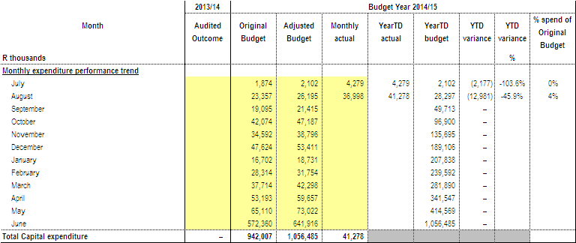
15.2 Capital Expenditure
BCMM has spent 4% inclusive of reclaimed vat (2013/14: 2%) of its 2014/15 rollover adjusted capital budget of R1.06 billion (2013/14: R856.36 million) with expenditure of R45.32 million (2013/14: R14.98 million) as at 31 August 2014. This reflects an improvement when compared to the same period in the previous financial year.

Refer to Annexure A – C5 for the breakdown per municipal vote, standard classification & funding; Annexure B – SC12 for monthly expenditure trends; SC13a for breakdown of asset classification for new assets and SC13b for breakdown on asset classification on renewal of existing asset).
A detailed schedule of the capital projects expenditure is outlined in Annexure E.

Table 29: Capital Expenditure per Funding Source against Budget
Funding | 2014/2015 Rollover Adjustment Budget | YTD Expenditure (VAT) incl) | Variance | % Exp.
Total Own Funding | 331,865,569 | 5,447,065 | 326,418,504 | 2%
DoE(Intergrated National Electrification Programme) | 27,000,000 | 163,152 | 26,836,848 | 1%
Department of Sports, Recreation, Arts and Culture c/o | 2,686,285 |  | 2,686,285 | 0%
Local Government, Traditional Affairs and Housing | 188,726 | 0 | 188,726 | 0%
Infrastructure Skills Development Grant | 100,000 | 0 | 100,000 | 0%
BCMET c/o | 256,818 |  | 256,818 | 0%
Leiden c/o | 458,860 |  | 458,860 | 0%
Neigbourhood Development Partnership Grant | 5,000,000 | 0 | 5,000,000 | 0%
Urban Settlement Development Grant | 639,824,500 | 34,106,465 | 605,718,035 | 5%
Human Settlement Development Grant | 49,103,948 | 5,600,847 | 43,503,101 | 11%
Total Grants | 724,619,137 | 39,870,465 | 684,748,672 | 6%
TOTAL PER FUNDING | 1,056,484,706 | 45,317,529 | 1,011,167,177 | 4%

Table 30: Actual Expenditure per Service against Budget

Services | 2014/2015 Rollover Adjustment Budget | YTD Expenditure (VAT) incl) | Variance | % Exp.
Water | 98,138,726 | 2,052,472 | 96,086,254 | 2%
Waste Water | 217,632,405 | 11,192,241 | 206,440,164 | 5%
Electricity | 137,747,400 | 1,018,953 | 136,728,447 | 1%
Roads and Stormwater | 188,000,000 | 11,266,802 | 176,733,198 | 6%
Housing | 100,764,115 | 12,786,898 | 87,977,217 | 13%
Transport Planning | 56,525,207 | 3,231,990 | 53,293,217 | 6%
Waste Management / Refuse | 95,783,621 | 645,779 | 95,137,842 | 1%
Amenities | 57,818,502 | 242,755 | 57,575,747 | 0%
Environmental Services | 10,000,000 | 0 | 10,000,000 | 0%
Health Services | 0 | 0 | 0 | 0%
Public Safety | 13,256,980 | 762,608 | 12,494,372 | 6%
Support Services | 48,520,082 | 228,498 | 48,291,584 | 0%
Other - BCM Fleet | 32,297,668 | 1,888,533 | 30,409,135 | 6%
 | 1,056,484,706 | 45,317,529 | 1,011,167,177 | 4%

Table 31: Actual Expenditure per Directorate against Budget

Directorate | 2014/2015 Rollover Adjustment Budget | YTD Expenditure (VAT) incl) | Variance | % Exp.
1. Executive Support Services | 6,798,257 | 0 | 6,798,257 | 0%
2. Municipal Manager's Office | 7,008,500 | 194,718 | 6,813,782 | 3%
3. Human Settlements | 100,805,255 | 12,801,604 | 88,003,651 | 13%
4. Directorate of Financial Services | 2,794,902 | 19,074 | 2,775,828 | 1%
5. Directorate of Corporate Services | 23,424,633 | 0 | 23,424,633 | 0%
6. Directorate of Engineering Services | 674,316,199 | 27,419,001 | 646,897,198 | 4%
7. Directorate of Development Planning | 46,525,207 | 3,231,990 | 43,293,217 | 7%
8. Directorate of Economic Development | 10,000,000 | 0 | 10,000,000 | 0%
9. Directorate of Health & Public Safety | 13,256,980 | 762,608 | 12,494,372 | 6%
10 .Directorate of Community Services | 163,865,123 | 888,534 | 162,976,589 | 1%
TOTAL DIRECTORATES | 1,048,795,056 | 45,317,529 | 1,003,477,527 | 4%
Asset Replacement | 7,689,650 |  | 7,689,650 | 0%
GRAND - TOTAL | 1,056,484,706 | 45,317,529 | 1,011,167,177 | 4%

15.3 Monthly Budget Statement – Capital Expenditure on New Assets by Asset Class
The capital programme performance tables provide summaries of capital expenditure by asset class and sub-class.

Table 32: SC13a Monthly budget Statement – capital expenditure on new assets
by asset class
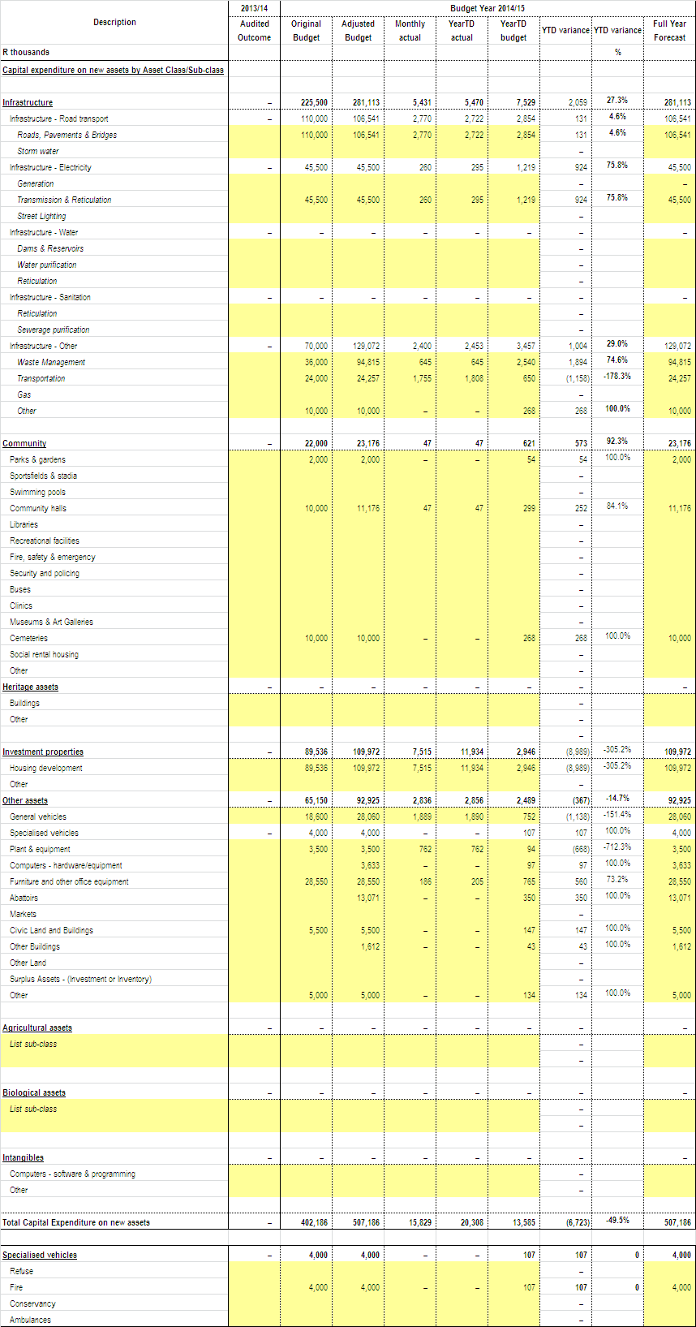

15.4 Monthly Budget Statement – Capital Expenditure on Renewal of Existing
Assets by Asset Class
Table 33: SC13b Monthly budget Statement – capital expenditure on renewal of existing assets by asset class

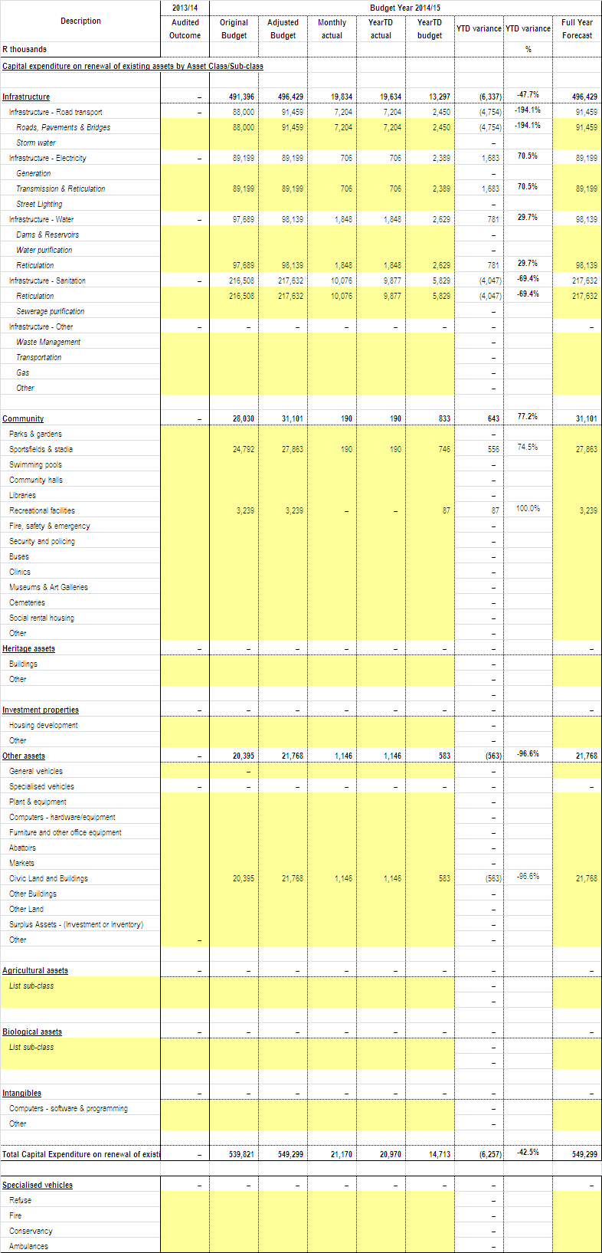

16. OTHER SUPPORTING DOCUMENTS
16.1 Operating Projects Expenditure

The Metro has spent 9% inclusive of reclaimed vat (2013/14: 2%) of its 2014/15 rollover adjustment budget of R288.44 million (2013/14: R357.01 million) with expenditure of R26.03 million as at 31 August 2014 (2013/14: R7.58 million). This reflects an improvement when compared to the same period in the previous financial year.

A detailed schedule of the operating projects expenditure is outlined in Annexure D. Below in tables 34 & 35 kindly find the summary for Annexure D

Table 34: Operating Projects per Directorate

OPERATING PROJECTS PER DIRECTORATE | 2014/2015 Rollover Adjustment Budget | YTD Expenditure (VAT) incl) | Variance | % Exp.
1. Executive Support Services | 1,755,165 | 36,106 | 1,719,059 | 2%
2. Municipal Manager's Office | 48,982,809 | 3,940,369 | 45,042,440 | 8%
3. Chief Operations Officer | 157,268,143 | 17,837,090 | 139,431,053 | 11%
4. Directorate of Financial Services | 42,961,602 | 477,405 | 42,484,197 | 1%
5. Directorate of Corporate Services | 14,364,938 | 759,896 | 13,605,042 | 5%
6. Directorate of Engineering Services | 2,000,000 | 0 | 2,000,000 | 0%
7. Directorate of Development Planning | 2,284,436 | 117,103 | 2,167,333 | 5%
8. Directorate of Economic Development | 13,439,408 | 482,244 | 12,957,164 | 4%
9. Directorate of Health & Public Safety | 277,788 | 0 | 277,788 | 0%
10. Directorate of Community Services | 5,103,534 | 2,377,262 | 2,726,272 | 47%
 | 288,437,823 | 26,027,475 | 262,410,349 | 9%

Table 35: Operating Projects per Funding Source

OPERATING PROJECTS PER FUNDING SOURCE | 2014/2015 Rollover Adjustment Budget | YTD Expenditure (VAT) incl) | Variance | % Exp.
Total Own Funding | 82,958,512 | 902,220 | 82,056,292 | 1%
Department of Land Affairs | 849,025 | 0 | 849,025 | 0%
Department of Local Government & Traditional Affairs | 4,790,672 | 402,906 | 4,387,767 | 8%
Department of Sport, Recreation and Arts and Culture | 37,438 | 0 | 37,438 | 0%
Department of Economic Development, Environmental Affairs and Tourism(DEDEAT) | 3,745,411 | 4,481 | 3,740,930 | 0%
European Commission | 500,000 | 0 | 500,000 | 0%
Expanded Public Works Programme Incentives Grant | 1,890,000 | 0 | 1,890,000 | 0%
Finance Management Grant | 1,500,000 | 301,660 | 1,198,340 | 20%
Human Settlement Development Grant | 142,523,295 | 17,352,928 | 125,170,367 | 12%
Infrastructure Skills Development Grant | 5,400,000 | 759,896 | 4,640,104 | 14%
Leiden | 136,315 | 0 | 136,315 | 0%
Local Government and Traditional Affairs | 6,101,371 | 2,377,262 | 3,724,109 | 39%
Premiers Fund | 67,421 | 0 | 67,421 | 0%
Trust Funds | 2,714,699 | 0 | 2,714,699 | 0%
Umsobomvu Youth Fund | 710,406 | 36,106 | 674,300 | 5%
Urban Settlement Development Grant | 33,464,500 | 3,890,015 | 29,574,485 | 12%
Vuna Awards | 1,048,758 | 0 | 1,048,758 | 0%
Total Grants | 205,479,311 | 25,125,254 | 180,354,057 | 12%
TOTAL PER FUNDING | 288,437,823 | 26,027,475 | 262,410,349 | 9%

17. INCOME AND EXPENDITURE REPORTS FOR DIRECTORATE OF HEALTH AND PUBLIC SAFETY & COMMUNITY SERVICES
17.1 HEALTH & PUBLIC SAFETY
Below is the table indicating the breakdown of the Cost Analysis indicating income and expenditure.
Table 36: Health & Public Safety – Cost Analysis
Health & Public Safety | Total Revenue | Employee Costs | Other Operating Expenditure | Repairs & Maintenance | Total Expenditure Excluding Capital
Office of the Dir P/Safety, Health, DM | 0 | 0 | 2,665 | 0 | 2,665
Support Services Office | 0 | 263,277 | 8,359 | 0 | 271,635
Health Administration | 0 | 481,477 | 64,163 | 0 | 545,639
Health Support | 0 | 0 | 2,544 | 0 | 2,544
Pharmacy | 0 | 0 | 1,640 | 0 | 1,640
Clinics | 0 | 0 | 157,684 | 9,541 | 167,225
Aids Training Information Centre | 0 | 0 | 41,538 | 0 | 41,538
Environmental Health | (394,406) | 2,490,902 | 413,298 | 5,504 | 2,909,704
Pest Control | -259 | 211,611 | 1,884 | 0 | 213,496
Pollution Control | 0 | 126,166 | 33,813 | 0 | 159,978
Educare Centres | 0 | 129,688 | 24,254 | 0 | 153,942
Public Safety Administration | 0 | 376,298 | 9,653 | 0 | 385,951
Fire and Rescue Services | (16,180,841) | 7,338,680 | 1,461,861 | 49,082 | 8,849,623
Security Services | (200) | 9,109,975 | 311,559 | 45,584 | 9,467,118
Traffic Administration | -3317 | 2,634,501 | 2,469,692 | 109,140 | 5,213,333
Traffic Control | (5,865) | 2,802,971 | 104,499 | 5,479 | 2,912,949
Criminal Process | (771,535) | 497,044 | 4,322 | 0 | 501,366
Vehicle Test Station / Examination | (70,296) | 553,948 | 37,519 | 0 | 591,467
Vehicle Registration | (9,622,238) | 740,287 | 38,632 | 0 | 778,919
Drivers License Testing | (2,228,337) | 770,684 | 83,804 | 0 | 854,488
Traffic Technical Services | 0 | 587,050 | 33,350 | 2,900 | 623,300
Parking Areas / Meters | -1851 | 748,106 | 10,669 | 0 | 758,775
Disaster Management | 0 | 254,485 | 100,219 | 648 | 355,352
Dog Tax Office | 24,225 | 111,849 | 5,711 | 1853.88 | 119,413
Total | (29,254,919) | 30,228,998 | 5,423,330 | 229,732 | 35,882,060
17.2 COMMUNITY SERVICES
Below is the table indicating the breakdown of the Cost Analysis indicating income and expenditure.

Table 37: Community Services – Cost Analysis
Community Services | Total Revenue | Employee Costs | Other Operating Expenditure | Repairs & Maintenance | Total Expenditure Excluding Capital
Office of Dir. Community Serv. | 0 | 1,455,325 | 51,933 | 3,597 | 1,510,854
Community Services Administration | 0 | 373,341 | 29,360 | 0 | 402,701
Environmental Administration Support | 0 | 329,040 | 17,213 | 0 | 346,252
Environmental Services | (19,560) | 8,966,506 | 908,131 | 47,659 | 9,922,296
Environmental Conservation | 0 | 1,821,542 | 84,644 | 0 | 1,906,187
Environmental Workshop | 0 | 685,174 | 34,480 | 395,535 | 1,115,189
Interments | (1,225,160) | 3,188,816 | 598,212 | 24,395 | 3,811,423
Gompo Admin Building | 0 | 0 | 0 | 0 | 0
Integrated Environmental Management | 0 | 166,284 | 6,556 | 294 | 173,135
Arts & Cultural Serv:Admin | 0 | 1,337,532 | 80,258 | 14,198 | 1,431,988
Libraries | (55,743) | 2,792,774 | 175,085 | 743 | 2,968,602
Art Gallery | 0 | 141,547 | 11,550 | 0 | 153,097
Art Centres | 0 | 0 | 1,798 | 0 | 1,798
Halls | (216,782) | 1,685,245 | 2,719,482 | 2,262 | 4,406,990
Amenities Administration Support | 0 | 828,857 | 151,519 | 48,836 | 1,029,213
Sportsfields | (31,525) | 2,362,342 | 626,702 | 108,948 | 3,097,992
Swimming Pools | (4,635) | 1,348,587 | 120,845 | 6,281 | 1,475,714
Aquarium | (23,986) | 1,152,861 | 148,777 | 0 | 1,301,638
Zoo | (164,706) | 781,624 | 244,215 | 39,362 | 1,065,202
Beaches | (7,708) | 1,829,382 | 419,602 | 89,176 | 2,338,160
Resorts | (136,208) | 778,334 | 223,395 | 61,088 | 1,062,817
Cleansing Administration Support | 0 | 1,515,862 | 1,752,085 | 251,890 | 3,519,838
Refuse Removal | (71,915,729) | 6,200,068 | 10,149,195 | 786,885 | 17,136,148
Waste Disposal Sites | (511,907) | 291,147 | 15,179 | 0 | 306,326
Street Sweeping | (1,665) | 6,206,768 | 74,647 | 0 | 6,281,416
Public Conveniences | 0 | 800,100 | 259,643 | 0 | 1,059,743
EL Regional Waste Disposal Site & Transfer Station | 0 | 1,058,855 | 2,786,438 | 0 | 3,845,293
Total | (74,315,313) | 48,097,914 | 21,690,947 | 1,881,150 | 71,670,011

18. MUNICIPAL MANAGER’S QUALITY CERTIFICATION

QUALITY CERTIFICATE

I, …………………………………, The City Manager of Buffalo City Metropolitan Municipality do hereby certify that –

- The monthly budget statement (Section 71 Report)
- Quarterly report on the implementation of the budget and financial state of affairs of the municipality
- Mid-year budget and performance assessment

for the period ending August 2014 has been prepared in accordance with the Municipal Finance Management Act 2003 and Regulations made under that Act.

Print name: ...........................................

City Manager of Buffalo City Metropolitan Municipality, BUF

Signature: ..........................................

Date: ...............................................

ANNEXURES:

Annexure A
C1 Monthly Budget Statement - Summary
C2 Monthly Budget Statement - Financial Performance (Std Classification)
C3 Monthly Budget Statement - Financial Performance (By Municipal Vote)
C4 Monthly Budget Statement - Financial Performance (Revenue and Expenditure)
C5 Monthly Budget Statement - Capital Expenditure (Municipal Vote, Std
Classification and Funding)
C6 Monthly Budget Statement - Financial Position
C7 Monthly Budget Statement - Cash Flow

Annexure B
SC1 Material Variance Explanation
SC2 Performance Indicators
SC3 Aged Debtors
SC4 Aged Creditors
SC5 Investment Portfolio
SC6 Transfers and Grants Receipts
SC7 (1) Transfers and Grants Expenditure
SC7 (2) Expenditure against approved rollovers
SC8 Councillor and Staff Benefits
SC9 Actuals and Revised Targets for Cash Receipts
SC12 Capital Expenditure trend
SC13a Capital Expenditure on New Assets by Class
SC13b Capital Expenditure on Renewal of Existing Assets by Class
SC13c Expenditure on Repairs and Maintenance by Asset Class
SC13d Depreciation by Asset Class

Annexure C
Schedule of Borrowings

Annexure D
Operating expenditure report

Annexure E
Capital expenditure report

