REPORT TO EXECUTIVE MAYOR: 14 NOVEMBER 2014
File No.:5/1/1/1[14/15]
Author: CITY MANAGER (ANDILE FANI)/VP

STATEMENT OF FINANCIAL PERFORMANCE AND THE IMPLEMENTATION OF THE 2014/15 BUDGET FOR THE PERIOD ENDING 31 OCTOBER 2014

1. PURPOSE
The purpose of the report is for the Executive Mayor to consider and note the statement of financial performance and the implementation of the 2014/15 budget of the Buffalo City Metropolitan Municipality for the period ending 31 October 2014.

2. AUTHORITY
Executive Mayor

3. LEGAL / STATUTORY REQUIREMENTS
3.1. The Constitution of the Republic of South Africa, 1996
3.2 Municipal Finance Management Act No 56, 2003 Chapter 7, Section 71
3.3. Municipal Budget and Reporting Regulations

4. PRESENTATION OF THE REPORT ON THE STATEMENT OF FINANCIAL
PERFORMANCE AND THE IMPLEMENTATION OF THE 2014/15 BUDGET FOR
THE PERIOD ENDING 31 OCTOBER 2014 IN TERMS OF THE MUNICIPAL
BUDGET AND REPORTING REGULATIONS
In terms of Section 71 of the Municipal Finance Management Act No 56, 2003, “the Accounting Officer of a municipality must by no later than 10 working days after the end of each month submit to the Mayor of the municipality and the relevant provincial treasury a statement in the prescribed format on the state of the municipality’s budget”.

The report which follows here below follows the legislative requirements of the Municipal Budget and Reporting Regulations.
TABLE OF CONTENTS

PART 1: ANNUAL BUDGET

5. | RESOLUTIONS | 5
6. | EXECUTIVE SUMMARY | 6
7. | IN-YEAR BUDGET STATEMENT TABLES | 9

PART 2: SUPPORTING DOCUMENTATION
8. | DEBTORS’ ANALYSIS | 18
9. | CREDITORS’ ANALYSIS | 23
10. | INVESTMENT PORTFOLIO ANALYSIS | 25
11. | ALLOCATION AND GRANT RECEIPTS AND EXPENDITURE | 28
12. | COUNCILLOR ALLOWANCES AND EMPLOYEE BENEFITS | 33
13. | MUNICIPALITY FINANCIAL PERFORMANCE | 41
14. | MUNICIPAL ENTITY FINANCIAL PERFORMANCE | 48
15. | CAPITAL PROGRAMME PERFORMANCE | 48
16. | OTHER SUPPORTING DOCUMENTS | 53
17. | INCOME AND EXPENDITURE REPORTS FOR DIRECTORATE OF HEALTH AND PUBLIC SAFETY & COMMUNITY SERVICES | 54
18. | MUNICIPAL MANAGER’S QUALITY CERTIFICATION | 57

LIST OF TABLES
TABLE 1 | Performance Summary | 6
TABLE 2 | C1: Monthly Budget Statement Summary | 9
TABLE 3 | C2: Monthly Budget Statement – Financial Performance (standard classification) | 10
TABLE 4 | C3: Monthly Budget Statement – Financial Performance (Revenue and expenditure by municipal vote) | 11
TABLE 5 | C4: Monthly Budget Statement – Financial Performance (Revenue by Source and Expenditure by Type) | 12
TABLE 6 | SC1: Material Variance Explanations for Revenue By Source and Expenditure by Type | 13
TABLE 7 | C5: Monthly Budget Statement – Capital Expenditure (municipal vote, standard classification and funding) | 14
TABLE 8 | C6: Monthly Budget Statement – Financial Position | 15
TABLE 9 | C7: Monthly Budget Statement – Cash Flow | 16
TABLE 10 | SC3 Monthly budget statement Aged Debtors | 18
TABLE 11 | Debtor’s Age Analysis as at 31 October 2014 | 19
TABLE 12 | Age Analysis per Category Type as at 31 October 2014 | 20
TABLE 13 | Cumulative Nett Billing, Receipts and Debtors Collection Ratio per month from 2012/13 to 2014/15 financial year | 21
TABLE 14 | Analysis of Government Debt as at 31 October 2014 | 22
TABLE 15 | SC4 Monthly budget Statement Aged Creditors | 23
TABLE 16 | 20 Highest Paid Creditors | 24
TABLE 17 | SC5 Monthly budget Statement – investment portfolio | 25
TABLE 18 | SC7 Monthly budget Statement – transfers and grants expenditure | 28
TABLE 19 | Spending per Conditional Grant Funding Allocation | 29
TABLE 20 | SC8: Monthly Budget Statement – Councillor and Staff Benefits | 34
TABLE 21 | Analysis of Overtime | 35
TABLE 22 | Overtime Per Cost Centre | 35
TABLE 23 | Analysis of Standby & Shift | 39
TABLE 24 | Analysis of Temporary Staff | 40
TABLE 25 | Analysis of Councillor Costs | 40
TABLE 26 | Statement of Financial Performance for the period ending 31 October 2014 | 42
TABLE 27 | Repairs and Maintenance per Directorate | 47
TABLE 28 | SC12 Monthly budget Statement – capital expenditure trend | 48
TABLE 29 | Capital Expenditure per Funding Source against Budget | 49
TABLE 30 | Actual Expenditure per Service against Budget | 49
TABLE 31 | Actual Expenditure per Directorate against Budget | 50
TABLE 32 | SC13a Monthly budget Statement – capital expenditure on new assets by asset class | 51
TABLE 33 | SC13b Monthly budget Statement – capital expenditure on renewal of existing assets by asset class | 52
TABLE 34 | Operating Projects per Directorate | 53
TABLE 35 | Operating Projects per Funding Source | 54
TABLE 36 | Health & Public Safety – Cost Analysis | 55
TABLE 37 | Community Services – Cost Analysis | 56

PART 1: IN-YEAR REPORT

5. RESOLUTIONS
It is recommended that:

- The Executive Mayor considers and notes the report on the statement of financial performance and the implementation of the 2014/15 budget for the period ending 31 October 2014 including supporting documentation attached as Annexure A to E.

- The Executive Mayor notes the spending rate on capital and operating projects as well as reasons for such as indicated in section 15.2 and 16.1 respectively of this report.

- The Executive Mayor notes the year to date collection rate for the period ending 31 October 2014 of 96% and the twelve (12) months average of 93%.

---------------------- -----------------------
CITY MANAGER DATE

6. EXECUTIVE SUMMARY ON THE IMPLEMENTATION OF THE BUDGET AND THE FINANCIAL STATE OF AFFAIRS OF THE MUNICIPALITY FOR THE PERIOD ENDING 31 OCTOBER 2014

6.1 Dashboard / Performance Summary
Table 1: Performance Summary
OVERALL OPERATING RESULTS |  | CASH MANAGEMENT
Income | R1,675,046,194 | Bank Balance | R 164,028,735
Expenditure | R 1,571,260,279 | Call investment deposits | R 2,015,163,901
Operating Surplus | R103,785,915 | Cash and cash equivalents | R 2,179,192,636
 |  | Total value of investments | R 2,025,134,782
 |  | Total investments - own funds | R 1,566,059,212
 |  | Total grants | R 459,075,570
 |  | Total Loans | R 587,762,030
DEBTORS |  | SURPLUS PER SERVICE
Total debtors book | R 1,012,403,669 | Water | R 23,959,254
Total debtors - Government | R 11,492,985 | Electricity | R 32,990,453
Total debtors - Business | R 118,341,338 | Refuse | R 20,708,690
Total debtors - Households | R 749,079,266 | Sewerage | R 69,322,512
Total debtors - Other | R 135,490,080
Total debt written off | R 103,488
CAPITAL EXPENDITURE |  | OPERATING PROJECTS EXPENDITURE
Capital Expenditure as a % of Adjusted Budget (2013/14: 15% of R856.36 million) | 18%  R187.43 million  (19%  R203.36 million incl. vat on conditional grant funding) | Operating Expenditure as a % of Adjusted Budget (2013/14: 12% of R357.01 million) | 24%  R68.87 million  (24%  R69.1 million incl. vat on conditional grant funding)
FINANCIAL |  | HUMAN RESOURCES
Operating Surplus for the period | R 103,785,915 | Total staff complement | 4,545
12 months average collection ratio | 93% | Staff Appointments | 325
YTD Grants and subsidies | R 301,832,776 | Staff Terminations | 84
Debtors to Revenue | 14.42% | Total overtime paid (YTD) | R 22,445,521
Percentage of Creditors paid within terms | 100% | Allowances and benefits- Councilors | R 15,098,069
Current ratio | 3.67:1 | Salary bill - Officials | R374,412,582
Total debt to Total assets | 4.29% | Workforce costs as a % of income | 22.4%
Capital Charges to Operating Expenditure | 16.33%

6.2 Liquidity position
Buffalo City Metropolitan Municipality’s liquidity is considered relatively sound as the Current Ratio is 3.67:1 which indicates the ability of Municipality’s current assets to cover its current liabilities. Debtors constitute 23% of the current assets, inventory constitutes 3% and cash & cash equivalents comprise 73% of the current assets.
6.3 Collection Rate and Outstanding Debtors
The debtor’s collection rate for the average twelve months ending 31 October 2014 is 93% (2013/14: 87.78%) and the year to date collection rate for the four (4) months is 96% (2013/14: 92.61%).

Total debtors book as at 31 October 2014 amounts to R1,01 billion (2013: R850.72 million). (Households: R749.08 million, Business: R118.34 million, Government: R11.49 million, Other: R135.49 million). The ratio of debtors to revenue is 14.42%. The debtors’ age analysis report is reflected on Annexure B – SC3.

6.4 Capital Expenditure
BCMM has spent 19% inclusive of reclaimed vat (2013/14: 15%) of its 2014/15 rollover adjusted capital budget of R1.06 billion (2013/14: R856.36 million) with expenditure of R203.36 million (2013/14: R129.82 million) as at 31 October 2014. This reflects an improvement when compared to the same period in the previous financial year. (Refer to Section 15.2)

A detailed schedule of the capital projects expenditure is outlined in Annexure E.

6.5 Operating projects
The Metro has spent 24% inclusive of reclaimed vat (2013/14:12%) of its 2014/15 rollover adjustment budget of R288.44 million (2013/14: R357.01 million) with expenditure of R69.1 million as at 31 October 2014 (2013/14: R42.58 million). This reflects an improvement when compared to the same period in the previous financial year.(Refer to Section 16.1)

A detailed schedule of the operating projects expenditure is outlined in Annexure D.

6.5 Expenditure on DoRA Current Allocation
The total expenditure inclusive of reclaimed vat on conditional grants DoRA allocation as at 31 October 2014 amounts to R155.25 million (R126.14) which is 22% (2013/14:17%) of the adjusted budget of R714.18 million (2013/14: R729.64). This reflects an improvement when compared to the same period in the previous financial year. (Refer to Section 11)

Urban Settlement Development Grant (USDG) funded projects
BCMM has spent 20% inclusive of reclaimed vat (2013/14: 19%) of its 2014/15 USDG budget of R673.29 million (2013/14: R613.31 million) with expenditure of R134.57 million (2013/14: R118.07 million) as at 31 October 2014.This reflects an improvement when compared to the same period in the previous financial year.

6.6 Cash and Cash Equivalents
The cash and cash equivalents of the City as at 31 October 2014 are R2.2 billion made up of conditional grants amounting to R459.08 million and own funds of R1.72 billion. This funding is invested with various financial institutions in compliance with the MFMA. Refer to Annexure A – C7 for the cash flow statement as well as Annexure B – SC5 for the investment portfolio breakdown.

6.7 Outstanding Creditors
The Metro is paying its creditors within 30 days as stipulated by the MFMA.The age creditor’s analysis is reflected in Annexure B –SC 4.

6.8 Long-Term Debt Profile
The total long term borrowings of the municipality as at 31 October 2014 amounts to R587.76 million (Refer to Annexure C for the schedule of borrowings).

The ratio of total debt to total assets is 4.29% and the total debt to revenue ratio is 14.32% as at 31 October 2014.

7. IN-YEAR BUDGET STATEMENT TABLES
7.1 Monthly Budget Statement Summary
The table below provides a high-level summation of the Metro’s operating and capital budgets, actuals to date, financial position and cash flow.

Table 2:C1: Monthly Budget Statement Summary
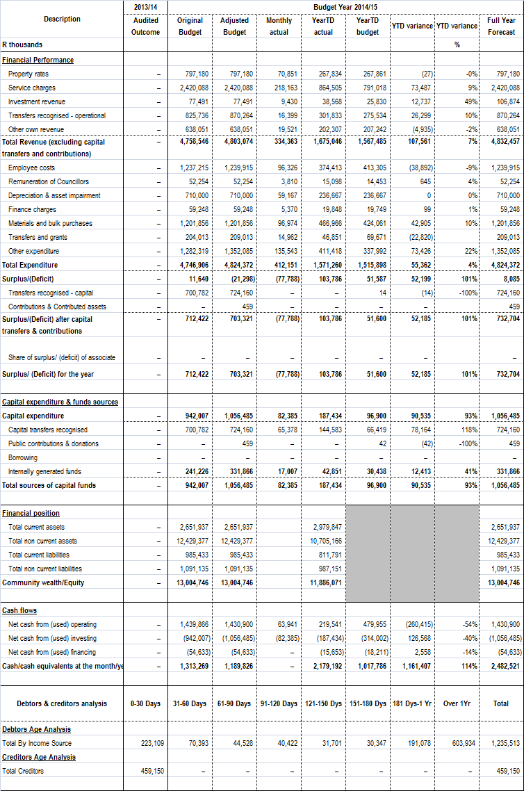

7.2 Monthly Budget Statement – Financial Performance (standard classification)
The table below is an overview of the budgeted financial performance in relation to revenue and expenditure per standard classification.

Table 3:C2: Monthly Budget Statement – Financial Performance (standard classification
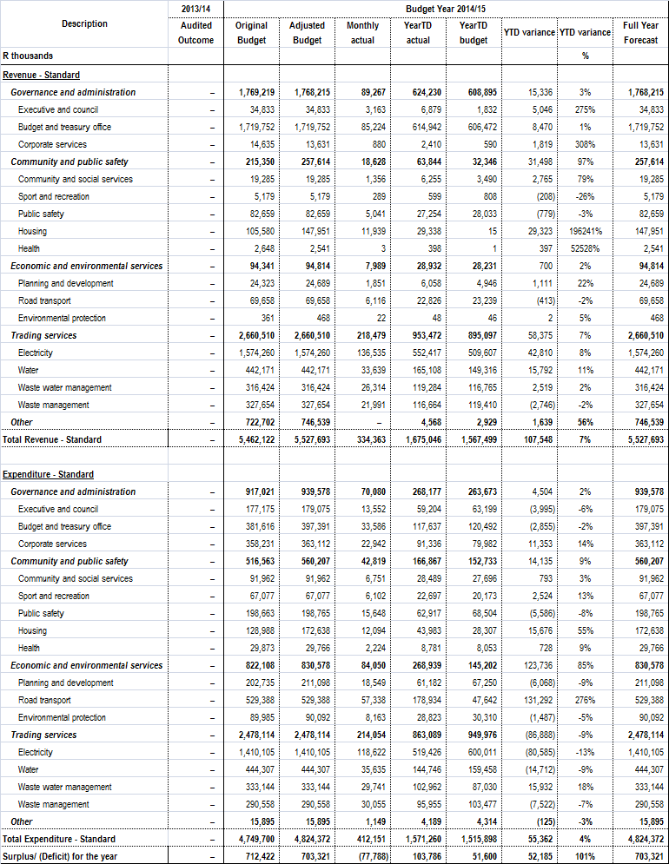

7.3 Monthly Budget Statement – Financial Performance (Revenue and expenditure by municipal vote)

The table below shows budgeted financial performance in relation to the revenue and expenditure by vote as well as the operating surplus or deficit.

Table 4:C3: Monthly Budget Statement – Financial Performance (Revenue and expenditure by municipal vote)
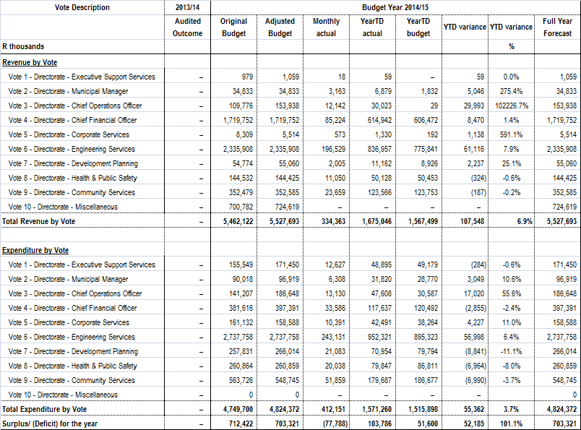

7.4 Monthly Budget Statement – Financial Performance (revenue by source and expenditure by type)

The table below is a view of the budgeted financial performance in relation to the revenue by source and expenditure by type.

Table 5: C4: Monthly Budget Statement – Financial Performance (revenue by source and expenditure by type)
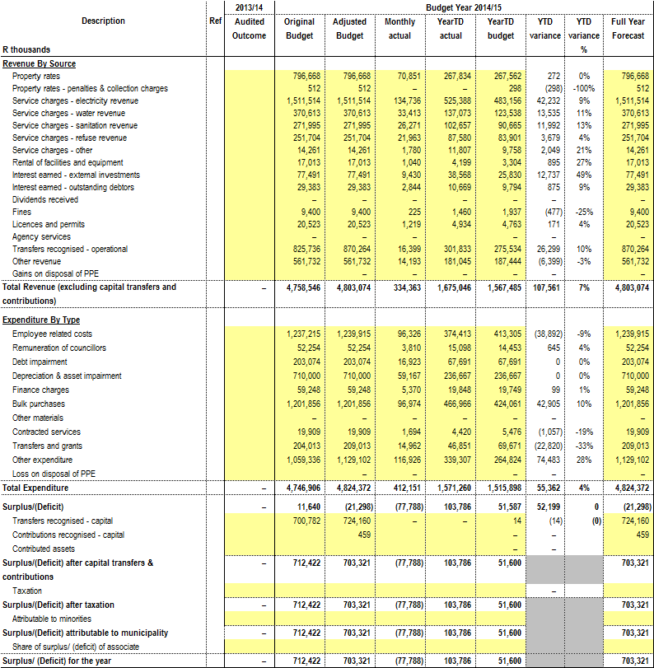

The following tables reflect all material (exceeding 10%) percentage variances for revenue and expenditure by type, reasons for material deviations and the remedial action thereof.

7.5 Material Variance Explanations for Revenue By Source and Expenditure by Type (Refer to Table C4)

Table 6: SC1: Material Variance Explanations for Revenue By Source and Expenditure by Type

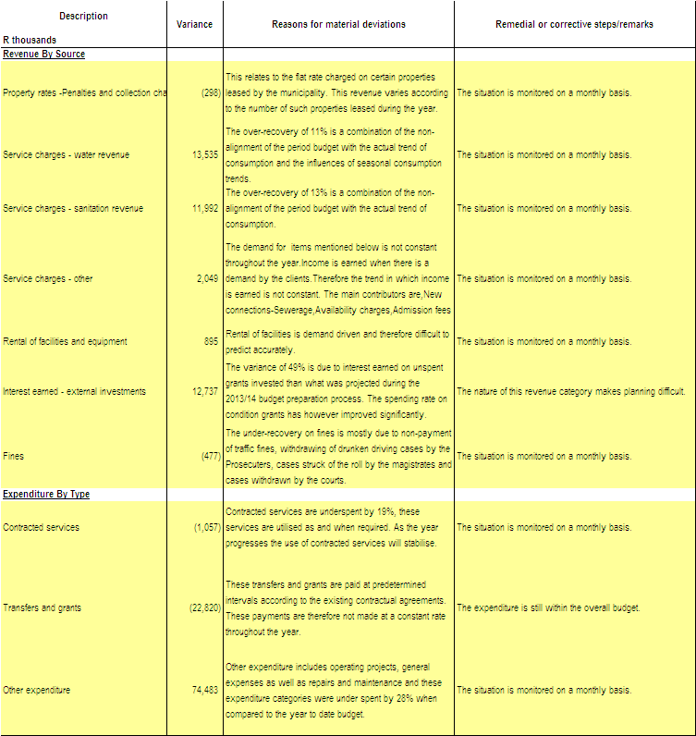

The table below reflects the Metro’s capital programme in relation to capital expenditure by municipal vote, capital expenditure by standard classification and funding sources required to fund the capital budget, including information on capital transfers from National and Provincial departments.

7.6 Capital Expenditure (municipal vote, standard classification and funding)

Table 7: C5: Monthly Budget Statement – Capital Expenditure (municipal vote, standard classification and funding)

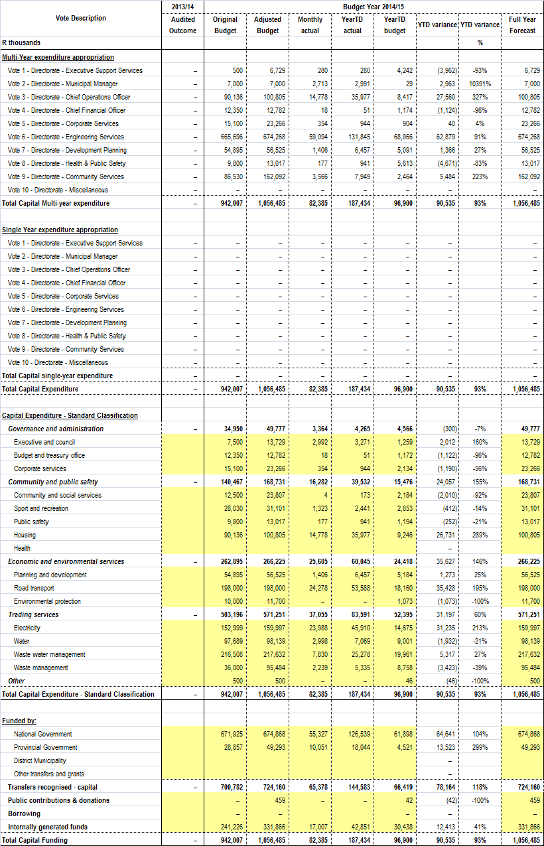
7.7 Monthly Budget Statement – Financial Position
The table below reflects the performance to date in relation to the financial position of the Metro.

Table 8: C6: Monthly Budget Statement – Financial Position
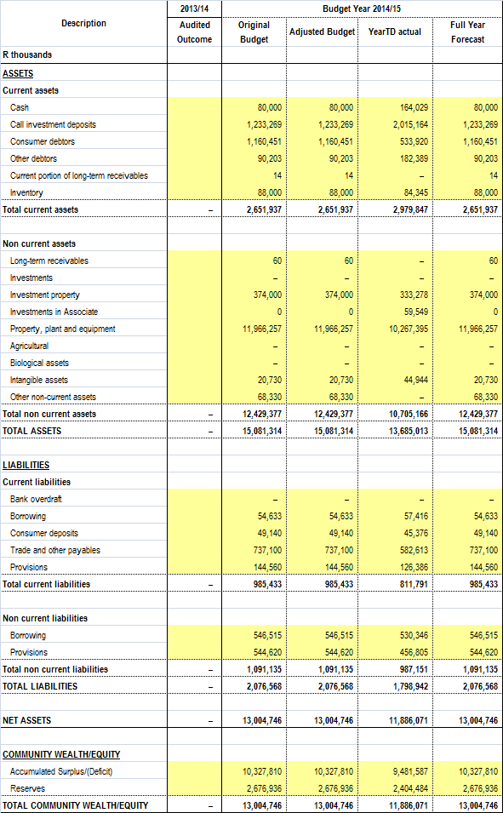
7.8 Monthly Budget Statement – Cash Flow
The Metro’s’ cash flow position and cash/cash equivalent outcome is shown in the table below.

Table 9: C7: Monthly Budget Statement – Cash Flow
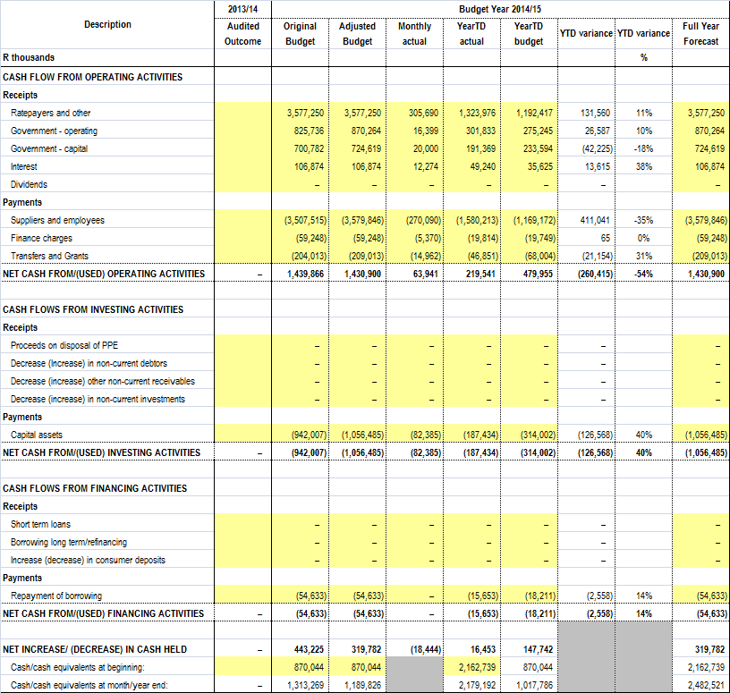

PART 2 -
SUPPORTING DOCUMENTATION

8. DEBTORS’ ANALYSIS
8.1 The debtor analysis provides an age analysis by revenue source and customer category.

Table 10: SC3 Monthly budget statement Aged Debtors
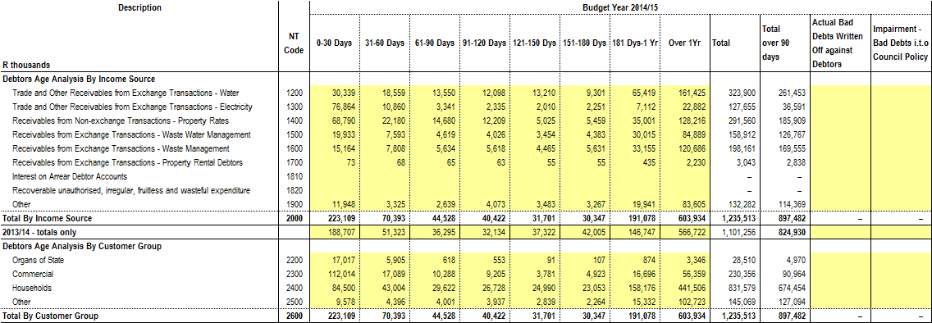

The arrears in respect of 30 days and more, which includes all charges, amounted to R1,012,403,668 at 31 October 2014 which is an increase of R20,731,258 over the amount of R991,672,410 at 30 September 2014. The primary reason for the increase relates to debtors who fail to settle their current accounts by the due date and therefore the debt ages into 30 days. No collection action can be taken prior to the due date.

Table 11: Debtor’s Age Analysis as at 31 October 2014
This Age analysis does not include debtors outstanding for less than 30 days.

AGEING | RATES | SEWERAGE | ELECTRICITY | WATER | REFUSE | SUNDRY  DEBTORS | TOTAL FOR  OCTOBER 2014 | TOTAL FOR  OCTOBER 2013
30 DAYS | 22,180,480 | 7,592,762 | 10,860,312 | 18,558,501 | 7,808,052 | 3,393,257 | 70,393,364 | 89,177,198
60 DAYS | 14,680,413 | 4,619,422 | 3,340,580 | 13,549,712 | 5,634,466 | 2,703,732 | 44,528,324 | 36,718,433
90 DAYS | 12,208,797 | 4,025,819 | 2,335,022 | 12,098,318 | 5,618,203 | 4,135,904 | 40,422,063 | 33,459,925
120 DAYS  TO 360 DAYS | 45,484,156 | 37,851,540 | 11,373,148 | 87,929,959 | 43,251,195 | 27,235,886 | 253,125,885 | 179,802,737
YEAR 2 | 38,361,101 | 26,500,235 | 7,833,676 | 54,424,804 | 34,159,118 | 24,359,675 | 185,638,611 | 149,788,552
YEAR 3 | 26,024,798 | 16,160,414 | 7,396,138 | 30,716,515 | 21,505,278 | 16,407,524 | 118,210,667 | 86,694,285
YEAR 4 | 18,325,025 | 9,718,862 | 2,481,096 | 18,148,394 | 13,067,971 | 10,224,730 | 71,966,078 | 68,582,151
YEAR 5 | 12,268,295 | 7,302,539 | 2,131,291 | 15,850,937 | 12,231,819 | 8,759,861 | 58,544,742 | 66,467,203
YEAR 5+ | 33,236,589 | 25,207,376 | 3,040,236 | 42,284,563 | 39,721,708 | 26,083,461 | 169,573,933 | 140,025,681
TOTAL | 222,769,654 | 138,978,969 | 50,791,500 | 293,561,704 | 182,997,810 | 123,304,031 | 1,012,403,668 | 850,716,167

8.2 Additional debtor’s information
8.2.1 Age Analysis per Category

Table 12: Age Analysis per Category Type as at 31 October 2014
CATEGORY TYPE | 30 DAYS | 60 DAYS | 90 DAYS | 120 DAYS+ | Total | % Share
Domestic | 28,607,317 | 16,848,008 | 14,944,467 | 415,758,991 | 476,158,782 | 47.03
Indigent | 14,097,143 | 12,645,714 | 11,674,812 | 231,258,379 | 269,676,048 | 26.64
Business | 17,089,316 | 10,287,781 | 9,204,854 | 81,759,387 | 118,341,338 | 11.69
Government | 5,904,501 | 618,158 | 552,502 | 4,417,824 | 11,492,985 | 1.14
MunicIpal Staff | 290,834 | 126,214 | 95,659 | 682,729 | 1,195,436 | 0.12
Councillors | 8,401 | 1,899 | 13,255 | 25,444 | 48,999 | 0.00
Other | 4,395,852 | 4,000,550 | 3,936,515 | 123,157,163 | 135,490,080 | 13.38
Total | 70,393,364 | 44,528,324 | 40,422,063 | 857,059,917 | 1,012,403,668 | 100.00

Note*: A stop order deduction is implemented for all municipal staff and councillors in arrears. When new staff join the employ of the municipality in many instances there is services debt, and therefore the arrears will be liquidated over an acceptable period of time, in terms of the Credit Control Policy. The reason why the debt reflects in the 30/60/90 day columns relating to staff and councillors is due to the fact that when the stop orders are receipted the payment is allocated to the oldest ageing category, giving the impression that current is not being paid, which is not the case as an amount is being deducted for current accounts.

8.2.2 Billing, Receipts and Debtors Collection Rate

Table 13: Cumulative Nett Billing, Receipts and Debtors Collection Ratio per month from 2012/13 to 2014/15 financial year

Month | 2012/2013 |  |  | 2013/2014 |  |  | 2014/2015
 | Billing | Receipts | Collection Rate | Billing | Receipts | Collection Rate | Billing | Receipts | Collection Rate
July | 238,333,589 | -155,444,098 | 90.42 | 2,325,509,002 | -2,153,249,916 | 92.59 | 2,602,264,135 | -2,371,903,619 | 91.00
August | 456,862,028 | -318,827,484 | 68.55 | 2,360,722,274 | -2,184,105,932 | 92.52 | 2,568,699,884 | -2,383,877,074 | 93.00
September | 637,913,507 | -509,870,368 | 77.58 | 2,362,100,818 | -2,201,573,537 | 93.20 | 2,589,585,746 | -2,403,569,317 | 93.00
October | 814,187,990 | -711,819,642 | 87.22 | 2,390,760,330 | -2,214,093,193 | 92.61 | 2,625,227,643 | -2,450,270,791 | 93
November | 1,003,917,047 | -884,987,889 | 89.60 | 2,413,236,105 | -2,237,227,839 | 92.71
December | 1,187,612,559 | -1,046,276,767 | 89.74 | 2,451,423,493 | -2,277,540,737 | 92.91
January | 1,376,713,577 | -1,219,332,883 | 89.58 | 2,473,521,774 | -2,288,389,311 | 92.52
February | 1,571,214,609 | -1,399,676,516 | 90.38 | 2,489,423,294 | -2,286,023,845 | 91.83
March | 1,756,245,816 | -1,575,792,522 | 90.40 | 2,508,588,241 | -2,317,244,720 | 92.37
April | 1,928,740,621 | -1,770,276,496 | 91.95 | 2,533,810,040 | -2,313,671,267 | 91.31
May | 2,136,072,369 | -1,952,779,796 | 93.19 | 2,563,282,383 | -2,324,079,609 | 90.67
June | 2,325,509,002 | -2,134,450,531 | 92.65 | 2,565,798,810 | -2,350,536,518 | 91.61

8.2.3 Government Accounts
The total arrears owed by Government Departments to Buffalo City Metropolitan Municipality as at 31 October 2014 amounted to R11,492,985.

Arrears as at 31 October 2014 R11,492,985
Arrears as at 30 September 2014 R13,338,177
Decrease (R 1,845,192)

A total payment of R52,951,586.10 was received from Government Departments in October 2014.The breakdown of the arrears per department is indicated in the table hereunder, as at 31 October 2014.Accounts in credit are excluded.

Table 14: Analysis of Government Debt as at 31 October 2014
DEPARTMENT | PROPERTY RATES | SERVICES | ARREARS AS AT  31 OCTOBER 2014 | ARREARS AS AT  30 SEPTEMBER 2014 | DIFFERENCE
National Department Of Public Works | 2,553,392 | 3,261,047 | 5,814,439 | 5,450,284 | 364,156
Provincial Department Of Public Works | 1,284,568 | 2,076,410 | 3,360,978 | 4,144,046 | (783,069)
Department Of Education |  | 1,942,114 | 1,942,114 | 2,270,688 | (328,574)
Department Of Health |  | 288,674 | 288,674 | 1,241,460 | (952,787)
Department Of Social Development |  | 25,402 | 25,402 | 135 | 25,267
Department Of Transport |  | - | - | 1,911 | (1,911)
Department Of Agriculture |  | - | - | 158,458 | (158,458)
Department Of Nature Conservation |  | - | - | - | -
Department of Community Development |  | 3,352 | 3,352 | 1,856 | 1,496
Sport, Recreation, Arts and Culture |  | - | - | - | -
Unemployment Insurance |  | - | - | - | -
Members Of Provincial Legislature |  | 49,604 | 49,604 | 69,339 | (19,735)
Department of Water Affairs |  | 8,421 | 8,421 | - | 8,421
TOTAL | 3,837,960 | 7,655,025 | 11,492,985 | 13,338,177 | (1,845,192)

Credit Control action is implemented to recover debt.

9. CREDITORS’ ANALYSIS
9.1 The creditors’ analysis contains an aged analysis by customer type.

Table 15: SC4 Monthly budget Statement Aged Creditors
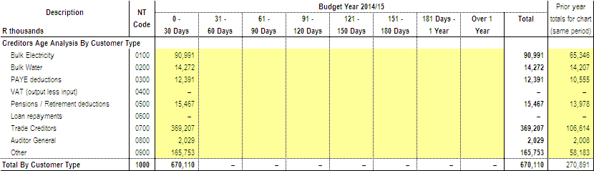

The amounts on this schedule are the actual payments made by BCMM to its creditors in October 2014.

Table 16: Payments made to the 20 highest Paid Creditors – October 2014
CREDITOR | 90 DAYS | 60 DAYS | 30 DAYS | CURRENT | TOTAL | PAYMENT
LUQAQMBO CIVILS CONSTRUCTION CC |  |  |  | 11,282,340.55 | 11,282,340.55 | 11,282,340.55
SHONE'S ELECTRICAL |  |  | 10,336,421.08 |  | 10,336,421.08 | 10,336,421.08
MANTELLA TRADING 522 CC |  |  |  | 8,472,625.86 | 8,472,625.86 | 8,472,625.86
SIYASEBENZA TARRING & CONSTRUCTION CC |  |  | 6,238,330.59 |  | 6,238,330.59 | 6,238,330.59
C & M FASTENERS CC |  |  | 4,586,950.09 |  | 4,586,950.09 | 4,586,950.09
GEAT SERVICES CC |  |  |  | 4,076,508.80 | 4,076,508.80 | 4,076,508.80
MAKINWA MEDIA MANAGEMENT |  |  |  | 3,288,052.59 | 3,288,052.59 | 3,288,052.59
LIFETIME CONNECTION MANUFACTURING SUPPLY CC |  |  |  | 3,079,382.29 | 3,079,382.29 | 3,079,382.29
RENNIES TRAVEL (PTY) LTD |  | 2,655,447.06 |  |  | 2,655,447.06 | 2,655,447.06
OTTO WASTE SYSTEMS (PTY) LTD |  |  |  | 2,548,420.08 | 2,548,420.08 | 2,548,420.08
2LL2M ENTERPRISE CC |  |  | 1,888,532.64 | 629,510.88 | 2,518,043.52 | 2,518,043.52
MASIQHAME TRADING 520 CC |  |  |  | 2,444,926.52 | 2,444,926.52 | 2,444,926.52
MVEZO JV ELITYENI |  |  |  | 2,324,030.82 | 2,324,030.82 | 2,324,030.82
SOYAMA CONSTRUCTION SERVICES CC |  |  | 2,043,862.50 |  | 2,043,862.50 | 2,043,862.50
EYA BANTU PROFFESSIONAL SERVICES CC |  |  |  | 2,039,242.65 | 2,039,242.65 | 2,039,242.65
MVEZO PLANT & CIVILS CC |  |  |  | 2,031,248.19 | 2,031,248.19 | 2,031,248.19
TSHUVANE SERVICES |  |  | 1,374,293.16 | 546,345.08 | 1,920,638.24 | 1,920,638.24
KEPU TRADING (PTY) LTD |  |  |  | 1,625,011.76 | 1,625,011.76 | 1,625,011.76
EAGLE UKHOZI TRANSPORT |  |  | 228,684.00 | 1,269,504.00 | 1,498,188.00 | 1,498,188.00
LIK'THEMBA BUILDING AND CONSTRUCTION CC |  |  |  | 1,307,780.50 | 1,307,780.50 | 1,307,780.50
TOTAL | - | 2,655,447.06 | 26,697,074.06 | 46,964,930.57 | 76,317,451.69 | 76,317,451.69

10. INVESTMENT PORTFOLIO ANALYSIS
10.1 The investment portfolio analysis includes information on the institution where funds are invested, period of investment, type of investment and accrued interest for the month.
Table 17: SC5 Monthly budget Statement – investment portfolio
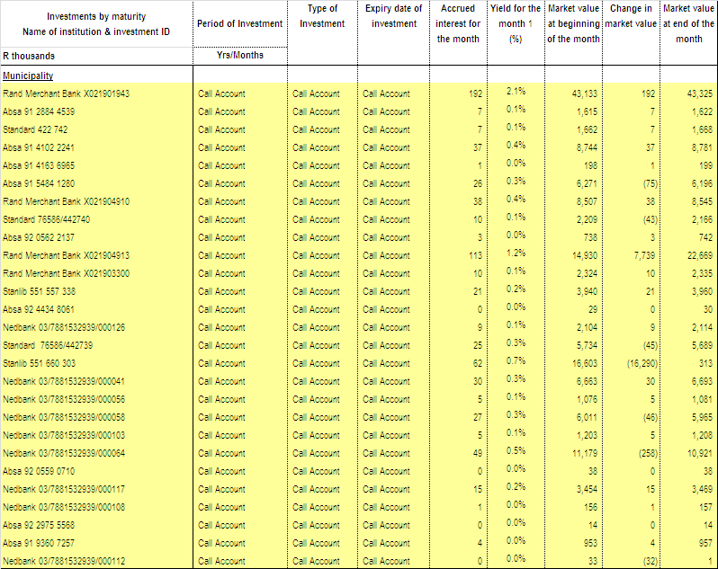
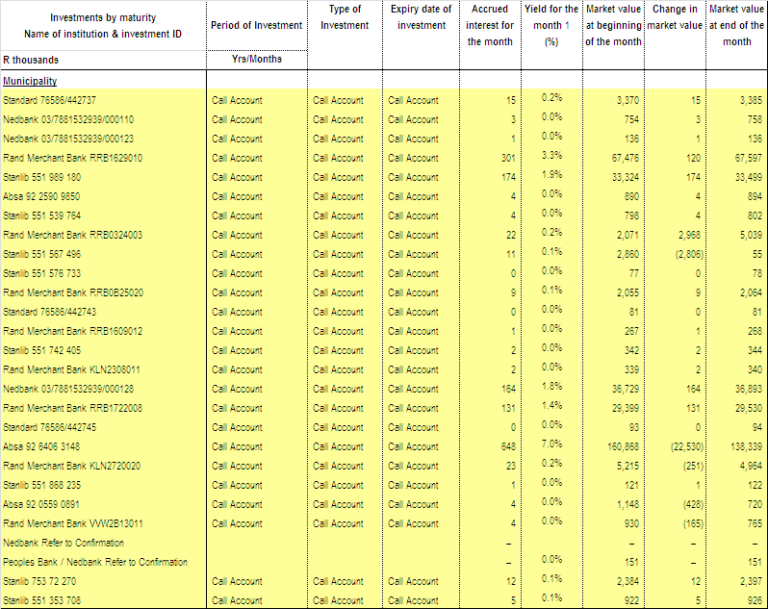
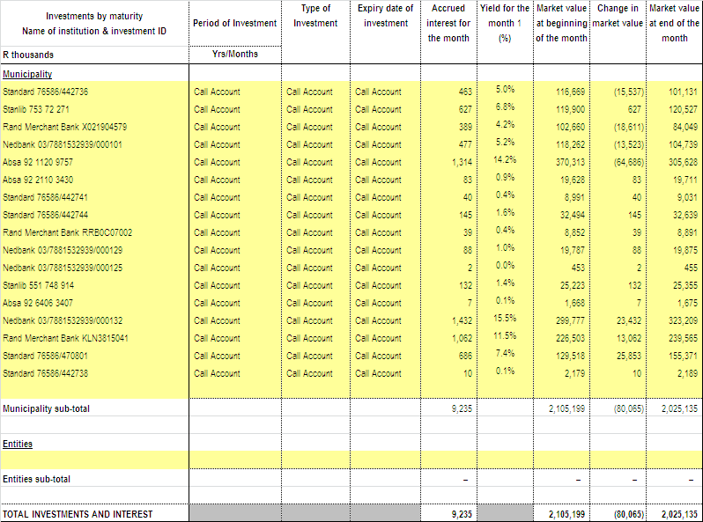
11. ALLOCATION AND GRANT RECEIPTS AND EXPENDITURE
11.1 Transfers and grants expenditure per allocation or grant is provided in the table below.
Table 18: SC7 Monthly budget Statement – transfers and grants expenditure
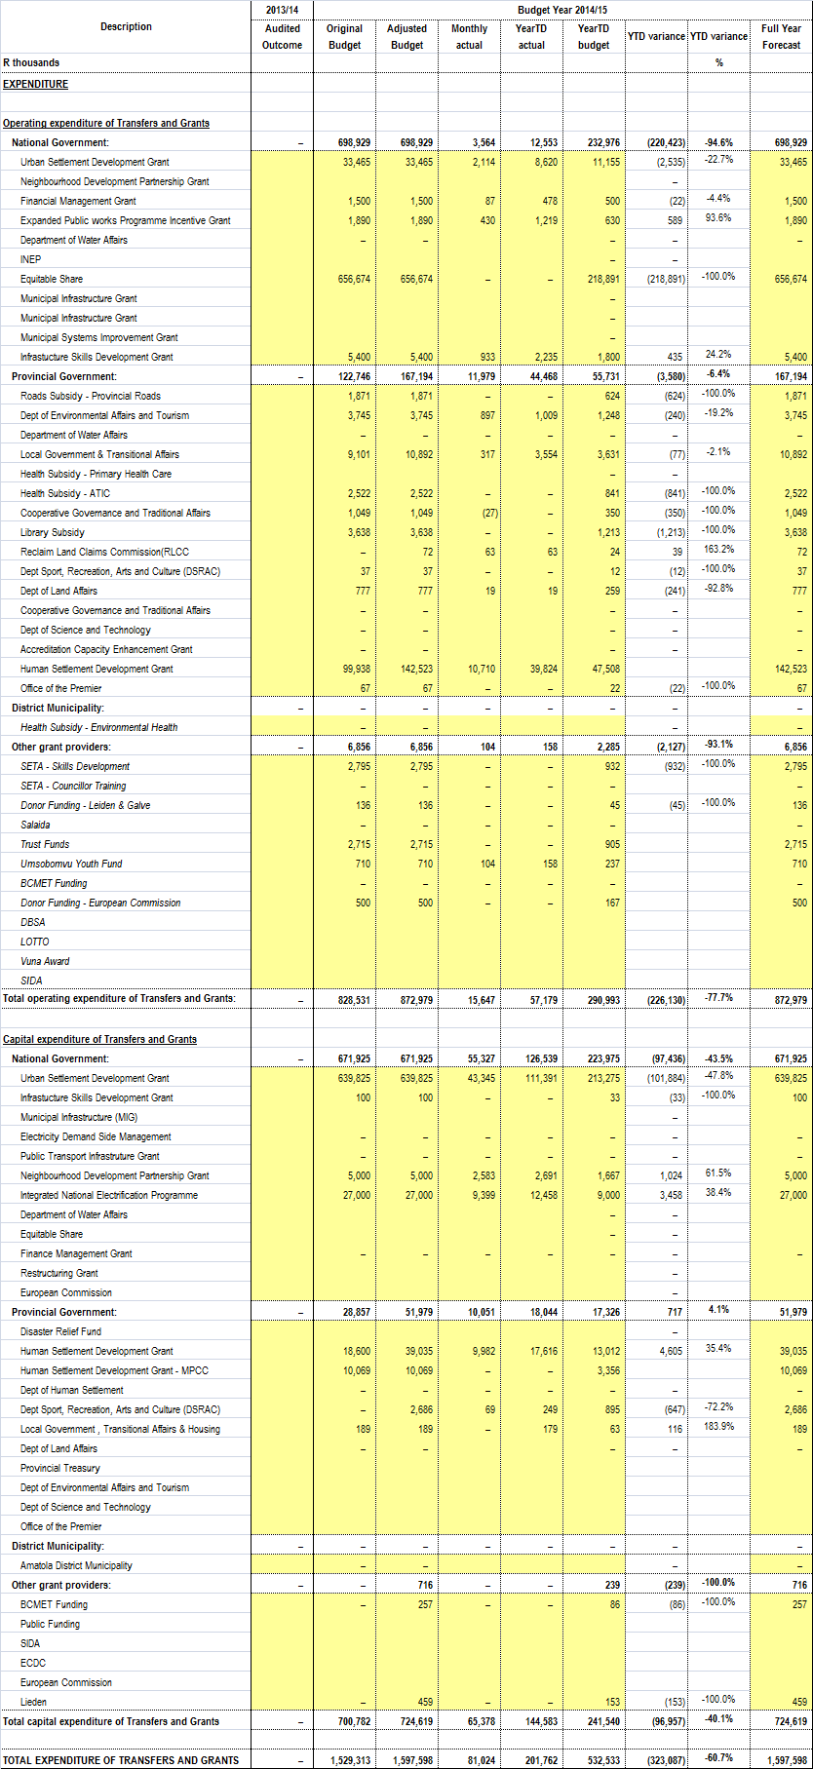
EXPENDITURE ON CONDITIONAL GRANT ALLOCATIONS
The total expenditure inclusive of reclaimed vat on conditional grants DoRA allocation as at 31 October 2014 amounts to R155.25 million which is 22% of the approved budget of R714.18 million.

Table 19 below reflects the year to date expenditure on 2014/15 total conditional grants.

Table 19: Spending per Conditional Grant Funding Allocation

Funding/Grant | 2014/2015 Approved Budget | YTD Expenditure | Variance | % Exp vs. Budget
DoE(Integrated National Electrification Programme) | 27 000 000 | 13 583 254 | 13 416 746 | 50%
Finance Management Grant | 1 500 000 | 477 936 | 1 022 064 | 32%
Infrastructure Skills Development Grant | 5 500 000 | 2 339 347 | 3 160 653 | 43%
Urban Settlement Development Grant | 673 289 000 | 134 566 387 | 538 722 613 | 20%
Neighbourhood Development Partnership | 5 000 000 | 3 067 921 | 1 932 079 | 61%
Expanded Public Works Programme | 1 890 000 | 1 219 430 | 670 570 | 65%
TOTAL | 714 179 000 | 155 254 275 | 558 924 725 | 22%

- INTERGRATED NATIONAL ELECTRIFICATION PROGRAMME (INEP)
Reasons for the Low Expenditure
The Intergrated National Electrification Programme is progressing well and will meet the target for full utilisation of funds at year end. There is no low expenditure, currently expenditure is sitting at 50%.

- FINANCE MANAGEMENT GRANT (FMG)
Reasons for the Low Expenditure
The funding will be utilised as follows: Implementation of Standard Chart of Accounts (SCOA), training of municipal officials in financial management towards attaining the minimum competencies and Interns remuneration. Recruitment of two additional interns will be done in the next month.

- INFRASTRUCTURE SKILLS DEVELOPMENT GRANT (ISDG)
The project is progressing well and will meet the target for full utilisation of funds at year end. There is no low expenditure, currently expenditure is sitting at 43%.

- URBAN SETTLEMENT DEVELOPMENT GRANT (USDG)

HOUSING
Reasons for the Low Expenditure
The planned appointment of service providers for the first quarter has been finalised, the required service providers are appointed, and are busy with planned work for the financial year. Most of the projects are currently under implementation, contractors are on site progressing with implementation. With regards to planning projects, designs are planned to be finalised within the first semester of the financial year (Amalinda Co - Op, Ilitha North and DVRI Pilot ~ Competition Site). Expenditure should improve within the next two quarters.

Corrective Measures to improve expenditure
The department has finalised the contractual documents and obligations with the newly appointed service providers (Mdantsane Custer 2, Mdantsane Zone 18cc, Cluster 3).These service providers have commenced with project implementation. The department has further planned to advance project monitoring in order to ensure that the service providers deliver as per required milestones. The submission dates for payment claims are to be revised in order to achieve the monthly targets and cashflows.

ENGINEERING SERVICES
Reasons for the Low Expenditure
Water and Sanitation Capital Projects
In one of the water contracts, a contractor has not performed well and the contract has been terminated.A treatment works project is being delayed due to community unrest and labour disruptions.

Corrective Measures to improve expenditure
Water and Sanitation Capital Projects
Contractors have commenced with the works on site on projects awarded and the progress is well. An annual contractor (contract 3) is used to finish the work for the contractor that has been terminated.

Sanitation Capital Projects
Funds have been spent on materials to be installed, and purchasing of electronic components for the Wastewater Treatment Works projects. Funds are also committed as 23 rural sanitation projects have been awarded to the value of R119 million. Contractors have commenced with the works on site on projects awarded and funds are fully committed.

DEVELOPMENT PLANNING & ECONOMIC DEVELOPMENT
Reasons for the Low Expenditure
KwaTshatshu Pedestrian Bridge: Project award August 2014. Inception stage complete and Feasibility Report submitted and approved. Environmental Impact stage, land ownership process and detailed design stage currently underway.

Needs Camp / Potsdam Bridge: Service Provider appointed and currently busy with detailed design phase. Environmental Impact stage and land ownership process underway in parallel.

Sidewalks: Sidewalks have been identified in Potsdam and Scenery Park and the work is in progress, in Mdantsane and Phakamisa still awaiting the orders.

Traffic Calming: Traffic calming measures have been completed in Beacon Bay, Cambridge, Braelyn Duncan Village and Sweetwaters, in Willow Park and Sunnyridge the work is in progress. In Zwelitsha and Mdantsane we are still waiting for the orders.

Guardrails: Guardrails have been identified in Mdantsane, Zwelitsha and Phakamisa and the implementation is in progress.

Traffic Signals: Traffic signals have been identified on NEX, Mdantsane Access Road, Potters Pass and Gullsway and the work is in progress and the cable informal tender has been advertised.

Guidance Signage: Guidance signs have been identified for the rural areas and they are in the stage of designs.

King William’s Town Public Transport Facilities: The designs for the project are at 95% complete and budget for implementation is still being requested through the office of the CFO.

Public Transport Facilities: Construction of Bus/Taxi Embayments in Cambridge, Scenary Park and Mdantsane in progress. Finalisation of way leaves for the construction of taxi rank in Bonza Bay Road currently at advance stage. Construction will start in Jan 2015.

Land Surveying: The service provider has completed the surveys for Fynbos I, Fynbos II and Ndancama for the provisional phase. Due to environmental challenges affecting the layout plan, and the fact that the shacks and bushes have not been removed, the project has come to a standstill. DEDEAT has given approval to go ahead with 80% of the Fynbos 1 and Fynbos II projects. This means that engineers can now finalize their engineering designs for the approved parts. The surveyor has amended the General Plans. The contractor has moved on site to construct TRA’s. Beaconing can commence once the site has been cleared of shacks.

Corrective Measures to improve expenditure
Land Surveying: The placing of internal beacons can only be done once the shacks and bush have been removed. As soon as the contractor moves on site and clears the bushes and the shacks, the land Surveyor can complete his work. The tender for the construction of the civil services and housing has been advertised and this tender includes the construction of a TRA which will be used to resettle the beneficiaries. Once the contractor is appointed, the beaconing can commence.

HEALTH AND PUBLIC SAFETY
Reasons for the Low Expenditure
KWT Traffic Building: Requirements submitted to service provider for the design of the building. Design plans currently being drawn up by the service provider.
Corrective Measures to improve expenditure
Meeting will be held on the 19th of November 2014 with Arch Branch & Service Provider to discuss preliminary designs.

COMMUNITY SERVICES
Reasons for the Low Expenditure
Development of Community Parks (Inland, Midland and Coastal): Specifications for playground equipment were approved on 29 August 2014. Requisitions & quotes for installation of Palisade Fencing amounting to R 658 023 were submitted to Supply Chain Management on 04 August 2014 for processing. Tender has been advertised for installation of park furniture.
Development of Cemeteries: An amount of R5 415 228 has been committed for the upgrading of road infrastructure.
Construction of Nompumelelo Hall: Contract 3021 was cancelled and new specifications to be submitted to the Bid Specification Committee on 07 November 2014.
Development and Upgrading of Community Halls: Tenders are in process for the refurbishment of Needs Camp Community Hall. And about War Memorial Hall and OR Thambo new parking areas, a site meeting was held with contractors on 19 September 2014.

- NEIGHBOURHOOD DEVELOPMENT PARTNERSHIP GRANT (NDPG)
The project is progressing well and will meet the target for full utilisation of funds at year end. There is no low expenditure, currently expenditure is sitting at 61%.

- EXPANDED PUBLIC WORKS PROGRAMME (EPWP)
The project is progressing well and will meet the target for full utilisation of funds at year end. There is no low expenditure, currently expenditure is sitting at 65%.
12. COUNCILLOR AND EMPLOYEE BENEFITS
12.1 Monthly Budget Statement – Councilor and Staff Benefits

Table 20: SC8 Monthly Budget Statement – Councilor and Staff Benefits

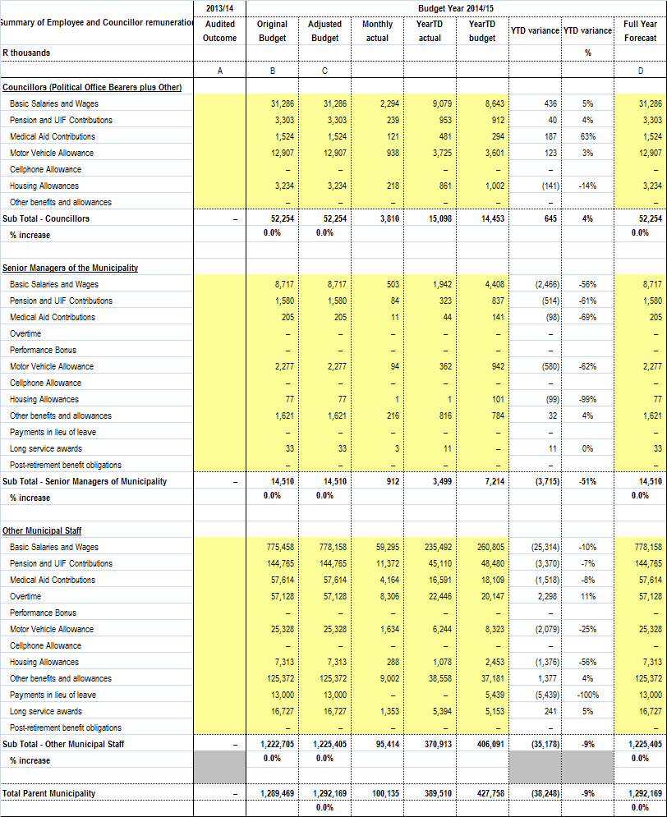

Table 21: ANALYSIS OF OVERTIME

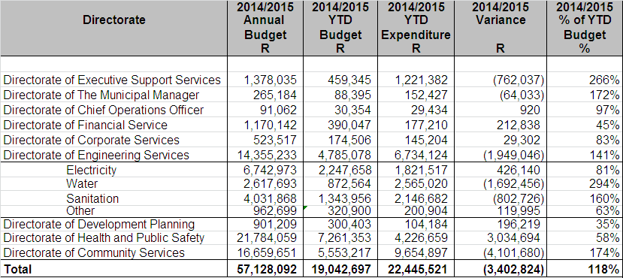

The municipality has overspent on its year to date overtime budget, as at 31 October 2014.

Table 22: OVERTIME PER COST CENTRE: JULY 2014 – OCTOBER 2014

Overtime per Cost Centre
 |  | August 2014 Amount | September 2014 Amount | October 2014 Amount
 | Directorate -Executive Support Services
105 005 | Office of The Director of Executive Support | 264 615.46 | 369 588.81 | 360 826.53
105 020 | Public Participation & Ward Committees | 4 917.22 | 3 750.87 | 27 196.16
105 025 | Strategic Support | - | - | 8 932.61
105 030 | Special Programmes | 239.13 | - | 6 961.57
120 010 | Public Relations & International Events | 40 317.76 | 54 229.74 | 67 611.89
 |  | 310 089.57 | 427 569.42 | 471 528.76
 | Directorate - Municipal Manager
205 005 | Office of The Municipal Manager & Support Services | 41 290.34 | 42 242.54 | 53 652.17
215 005 | Internal Audit | - | 3 473.12 | -
225 010 | Municipal Public Accounts Committee | 11 769.18 | - | -
 |  | 53 059.52 | 45 715.66 | 53 652.17
 | Directorate - Chief Operations Officer
250 005 | Office of the Chief Operations Officer | 16 728.52 | 11 547.12 | -
255 005 | Housing Department | - | - | 3 261.60
 |  | 16 728.52 | 11 547.12 | 3 261.60
 | Directorate - Chief Financial Officer
305 005 | Office of The Director of Finance | - | 3 649.51 | -
305 010 | Support Services Office | - | - | 11 434.25
315 005 | Budget Office | 8 219.84 | 10 658.98 | 8 574.50
320 010 | Supply Chain Management | -68 277.65 | 8 687.96 | 17 469.25
320 015 | Expenditure Office | 7 760.99 | - | 6 503.76
320 020 | Salary Office | 2 254.11 | 569.63 | -
330 005 | Rates & Valuations Office | - | 2 031.86 | -
330 010 | Consolidated Billing & Miscellaneous Revenue Office | 422.59 | 8 766.72 | 15 471.07
330 015 | Debtors Management Office | 56 599.88 | 44 304.08 | 11 097.30
330 020 | Customer Care Office | 13 004.87 | 18 936.81 | 24 720.43
330 025 | Pre-Payment Vending Office | - | - | -
 |  | 19 984.63 | 97 605.55 | 95 270.56
 | Directorate - Corporate Services
405 005 | Office of The Director of Corporate Services | - | 1 021.76 | -
415 005 | Administrative & Council Support | 888.56 | 1 100.32 | 2 657.51
415 010 | Auxilliary & Telecommunication Services | 18 444.87 | 26 853.49 | 24 948.61
415 025 | Management Information Services | 7 326.08 | 3 528.10 | 4 605.26
420 005 | H.R. Administration | 14 883.53 | 9 766.15 | 20 111.87
420 010 | Occupational Risk Management | - | 8 248.66 | 4 961.60
 |  | August 2014 Amount | September 2014 Amount | October 2014 Amount
420 015 | Labour Relations | - | - | 1 680.14
425 005 | Research Policy & Knowledge Management Unit | - | -576.68 | 11 602.49
 |  | 41 543.04 | 49 941.80 | 70 567.48
 | Directorate - Engineering Services
505 005 | Office of The Director of Engineering Services - Admin | 1 430.64 | 1 192.20 | 9 952.09
505 010 | City Engineering Building | 3 629.15 | 1 961.70 | 1 471.28
505 015 | Chiselhurst, Beacon Bay & Kwt Depot | 15 260.16 | 18 717.54 | 18 598.32
510 005 | Scientific Services | 1 752.44 | - | -
515 006 | Night Soil Removal - Coastal | 42 216.59 | 51 443.52 | 164 976.89
515 007 | Night Soil Removal - Central | 2 381.12 | 4 827.75 | -
515 010 | Sewerage Admin | - | - | 13 249.00
515 026 | Sewerage Treatment - Coastal | 48 043.33 | 37 771.77 | 42 807.74
515 027 | Sewerage Treatment - Central | 34 712.24 | 32 076.88 | 43 169.42
515 028 | Sewerage Treatment - Inland | 46 989.34 | 100 940.13 | 55 615.77
515 031 | Sewerage Reticulation - Coastal | 181 798.09 | 184 283.42 | 323 188.12
515 032 | Sewerage Reticulation - Central | 93 038.18 | 112 715.54 | 244 051.87
515 033 | Sewerage Reticulation - Inland | 79 650.75 | 103 717.49 | 103 017.22
520 005 | Water Administration | 2 436.81 | 19 379.94 | 8 845.61
520 011 | Maden Dam | 13 012.50 | 22 375.92 | 12 971.70
520 012 | Bridle Drift Dam | - | 2 565.36 | 6 779.88
520 015 | Bulk Pumping Stations | 10 119.77 | 24 565.98 | 20 663.88
520 021 | Umzonyana Water Treatment Works | 41 304.48 | 62 454.60 | 43 632.81
520 023 | KWT Water Treatment Works | 116 771.24 | 102 060.20 | 99 478.57
520 024 | Mdantsane Bulk Pumping | - | 37 166.75 | 54 846.56
520 025 | Water Ops & Maint. - Inland | 247 432.11 | 140 768.64 | 160 987.25
520 026 | Water Ops & Maint. - Midland | 185 240.46 | 215 716.83 | 194 340.67
520 030 | Water Ops & Maint. - Coastal | 234 274.33 | 234 831.59 | 249 995.51
525 005 | Construction Distribution | - | - | 2 433.48
525 010 | Roads Administration | 3 910.94 | - | 908.48
525 025 | Roads & Stormwater Drainage | 23 891.20 | 4 641.33 | 523.12
530 005 | Mechanical Workshop - Westbank | - | 1 310.70 | -
530 010 | Fleet Management - Westbank | 1 539.00 | - | 769.50
530 015 | Mechanical Workshop - Braelyn | 19 481.97 | 41 035.67 | 26 078.39
535 005 | Electricity Administration | 2 146.28 | 2 146.28 | 1 933.30
535 010 | Electricity Distribution Supervisory Staff | 455 674.22 | 577 064.79 | 606 537.97
535 025 | Electricity Planning & Design | 655.35 | 589.82 | 688.13
535 040 | Revenue Protection | 52 806.19 | 62 088.07 | 59 186.82
 |  | 1 961 598.88 | 2 200 410.41 | 2 571 699.35
 | Directorate - Development Planning
615 070 | City Planning | -5 012.70 | - | -
615 095 | Building Maintenance - Coastal / Central | - | - | 9 851.91
620 015 | Traffic Signal Maintenance | 7 046.46 | 10 151.04 | 8 146.12
625 005 | Buffalo City Bus Services | 10 661.30 | - | 22 391.62
 |  | August 2014 Amount | September 2014 Amount | October 2014 Amount
635 010 | Market | 14 006.42 | 10 320.29 | 16 621.59
 |  | 26 701.48 | 20 471.33 | 57 011.24
 | Directorate - Health & Public Safety
710 030 | Environmental Health | - | - | 17 803.12
725 005 | Public Safety Administration | 4 613.22 | -4 613.22 | -
725 010 | Fire & Rescue Services | 216 957.04 | 242 908.44 | 225 679.55
725 015 | Law Enforcement Services | 780 625.36 | 833 623.65 | 758 465.42
725 020 | Traffic Administration | 42 702.91 | 84 850.42 | 60 282.03
725 025 | Traffic Control | 198 001.59 | 302 831.93 | 291 607.49
725 030 | Criminal Process | 3 502.50 | - | 223.02
725 035 | Vehicle Test Station / Examination | 4 974.07 | 2 601.40 | 5 893.53
725 045 | Traffic Technical Services | 7 053.62 | -5 111.12 | 5 343.12
725 050 | Parking Areas / Meters | 25 217.54 | 46 768.25 | 63 764.15
725 055 | Disaster Management | 2 265.32 | 2 455.83 | 5 568.80
 |  | 1 285 913.17 | 1 506 315.58 | 1 434 630.23
 | Directorate - Community Services
750 005 | Office of The Director of Community Services | 43 774.68 | 51 478.36 | 74 208.37
750 010 | Cleansing Administration Support | 1 666.80 | 2 833.56 | 43 524.93
755 010 | Environmental Services | 370 253.36 | 333 498.69 | 380 664.56
755 015 | Environmental Conservation | 142 994.62 | 164 070.45 | 196 843.89
755 020 | Environmental Workshop | 1 219.61 | 2 571.50 | 6 411.54
755 025 | Interments | 315 805.58 | 309 088.58 | 267 505.51
760 005 | Arts & Cultural Services Admin | 33 080.71 | 30 288.22 | 42 515.31
760 010 | Libraries | 11 554.46 | 12 819.72 | 11 097.64
760 015 | Art Gallery | 497.28 | 3 858.12 | 3 498.04
760 025 | Halls | 130 391.22 | 169 669.09 | 169 637.47
765 005 | Amenities Administration Support | 19 530.99 | 5 097.12 | 26 136.31
765 010 | Sportsfields | 78 294.93 | 127 809.94 | 162 123.50
765 015 | Swimming Pools | 5 943.66 | 9 330.43 | 130 253.23
765 020 | Aquarium | 26 412.12 | 36 450.12 | 41 915.76
765 025 | Zoo | 53 437.40 | 70 149.95 | 57 565.50
765 030 | Beaches | 148 622.90 | 183 739.40 | 169 376.20
765 035 | Resorts | 48 470.77 | 68 242.75 | 51 248.89
770 005 | Cleansing Administration Support | 53 022.47 | 49 695.41 | 69 391.23
770 010 | Refuse Removal | 625 574.79 | 650 324.69 | 817 573.23
770 015 | Waste Disposal Sites | 14 856.59 | 19 606.35 | 20 993.48
770 020 | Street Sweeping | 628 238.21 | 707 330.63 | 706 168.93
770 025 | Public Conveniences | 100 317.58 | 118 909.89 | 100 019.51
770 030 | E.L Regional Waste Disposal Site & Transfer Station | 32 157.52 | 47 978.44 | 45 264.30
 |  | 2 886 118.25 | 3 174 841.41 | 3 593 937.33
 | TOTAL OVERTIME | 6 601 737.06 | 7 534 418.28 | 8 351 558.72

COMMENTS ON OVERTIME
- Directorate of Executive Support Services
The planned and emergency nature of tasks within the Executive Mayors’ Office contribute to excessive hours of work. Overtime incurred is also due to ward committee meetings, Inter-departmental and Inter-Governmental Relation programmes.

- Municipal Managers Office
The over expenditure on overtime is due to unplanned and emergency overtime; staff is required to remain in office as there is Audit taking place. Monitoring of overtime is still taking place.

- Chief Operations Officer
Overtime is spent when there is a need by the personnel working in Beneficiary Administration, Relocation and Education who have to work odd hours because of non availability of beneficiaries on normal working hours. Expenditure is incurred as per demand for such services.

- Directorate of Engineering Services

Water - Carrying out emergencies due to the high number of pipe bursts received and planned overtime for shifts and standby.

Sanitation - Carrying out emergencies (burst rising mains etc.) and attending to alarms received via the telemetry system of faults at pump stations i.e. tripped pumps etc.

- Directorate of Community Services
Overtime is mostly aligned to halls usage , high volume of burials especially over weekends and the emergency overtime for grass cutting and vegetation control.

The Amenities functions are of such a nature that certain staff must be available seven days a week including public holidays. Services provided include emergency work over the holiday seasons, swimming pools (inland/ costal), sportsfields (inland/ coastal), resorts, aquarium, beaches, coastal conservation, nature reserves and the zoo.
Table 23: Analysis of Standby & Shift
 | AUGUST 2014 | SEPTEMBER 2014 | OCTOBER  2014
Directorate – Executive Support Services | 12 226 | 13 804 | 38 839
Directorate – Municipal Manager | 6 611 | 973 | 1 026
Directorate – Chief Financial Officer | 5 721 | 6 238 | 5 059
Directorate – Corporate Services | 13 524 | 14 434 | 13 329
Directorate – Engineering Services | 458 068 | 463 967 | 791 936
Directorate – Development Planning | 9 168 | 9 022 | 11 451
Directorate – Health & Public Safety | 171 775 | 193 918 | 182 472
Directorate – Community Services | 230 207 | 216 778 | 234 974
TOTAL | 907 301 | 919 133 | 1 279 085

The total standby and shift payment for the months of August 2014, September 2014 and
October 2014 is reflected above. There was an increase in the total payment between August 2014 and September 2014 of R11 832 and an increase in the total payment between September 2014 and October 2014 of R359 952.

12.2 COST OF TEMPORARY STAFF

Table 24: Analysis of Temporary Staff

 | AUGUST 2014 | SEPTEMBER 2014 | OCTOBER  2014
Directorate – Executive Support Services | 1 096 557 | 1 195 442 | 1 011 184
Directorate – Municipal Manager | 128 754 | 193 274 | 339 958
Directorate – Chief Operations Officer | 403 131 | 404 431 | 431 445
Directorate – Chief Financial Officer | 1 219 352 | 876 366 | 1 339 440
Directorate – Corporate Services | 847 704 | 991 753 | 744 906
Directorate – Engineering Services | 291 042 | 181 645 | 382 980
Directorate – Development Planning | 172 174 | 71 713 | 74 969
Directorate – Health & Public Safety | 3 634 902 | 3 626 190 | 3 460 207
Directorate – Community Services | 3 651 431 | 3 113 151 | 4 205 269
TOTAL | 11 445 048 | 10 653 964 | 11 990 359

The total payment of Temporary Staff for the months of August 2014, September 2014 and
October 2014 is reflected above. There was a decrease in the total payment between August 2014 and September 2014 of R791 084 and an increase in the total payment between September 2014 and October 2014 of R1 336 394.

12.3 COUNCILLORS COSTS
 | OCTOBER  2014 | YTD  EXPEN | YTD  BUDGET | VARIANCE | ANNUAL BUDGET
Mayoral Allowance | 56 078 | 224 312 | 248 133 | 23 820 | 744 398
Deputy Mayoral  Allowance | 44 862 | 179 450 | 198 506 | 19 056 | 595 518
Mayoral Committee Allowance | 378 527 | 1 514 106 | 1 860 994 | 346 888 | 5 582 983
Speakers Allowance | 44 862 | 179 450 | 197 689 | 18 239 | 593 067
Councillors Allowance | 1 769 572 | 6 981 711 | 7 923 315 | 941 604 | 23 769 946
Cllr Housing Subsidy | 217 645 | 860 851 | 1 077 976 | 217 125 | 3 233 928
Cllr Medical Aid | 121 327 | 480 895 | 507 959 | 27 064 | 1 523 877
Cllr Pension Scheme | 238 893 | 952 626 | 1 041 598 | 88 971 | 3 124 793
Cllr Travel Allowance | 938 111 | 3 724 668 | 4 302 440 | 577 773 | 12 907 321
Cllr U.I.F | - | - | 59 488 | 59 488 | 178 464
TOTAL | 3 809 878 | 15 098 069 | 17 418 098 | 2 320 029 | 52 254 295

Table 25: Councillors Costs

The Annual Budget of R52 254 295 prorated per month gives a Year to Date Budget for the month of October 2014 of R17 418 098. The Year to Date Budget less the Year to Date Expenditure of R15 098 069 leaves a Variance of R2 320 029.

13. MUNICIPALITY FINANCIAL PERFORMANCE

13.1 Statement of Financial Performance

The Statement of Financial Performance presented below, compares the expenditure and revenue on accrual basis against budget for the period ending 31 October 2014.
Table 26: Statement of Financial Performance for the period ending 31 October 2014

Description | 2013/14 | Budget Year 2014/15
Description | Audited Outcome | Original Budget | Adjusted Budget | Monthly actual | YearTD actual | YearTD budget | YTD variance | YTD variance | Full Year Forecast
R thousands |  |  |  |  |  |  |  | %
Revenue By Source
Property rates |  | 796,668 | 796,668 | 70,851 | 267,834 | 267,562 | 272 | 0% | 796,668
Property rates - penalties & collection charges |  | 512 | 512 | – | – | 298 | (298) | -100% | 512
Service charges - electricity revenue |  | 1,511,514 | 1,511,514 | 134,736 | 525,388 | 483,156 | 42,232 | 9% | 1,511,514
Service charges - water revenue |  | 370,613 | 370,613 | 33,413 | 137,073 | 123,538 | 13,535 | 11% | 370,613
Service charges - sanitation revenue |  | 271,995 | 271,995 | 26,271 | 102,657 | 90,665 | 11,992 | 13% | 271,995
Service charges - refuse revenue |  | 251,704 | 251,704 | 21,963 | 87,580 | 83,901 | 3,679 | 4% | 251,704
Service charges - other |  | 14,261 | 14,261 | 1,780 | 11,807 | 9,758 | 2,049 | 21% | 14,261
Rental of facilities and equipment |  | 17,013 | 17,013 | 1,040 | 4,199 | 3,304 | 895 | 27% | 17,013
Interest earned - external investments |  | 77,491 | 77,491 | 9,430 | 38,568 | 25,830 | 12,737 | 49% | 77,491
Interest earned - outstanding debtors |  | 29,383 | 29,383 | 2,844 | 10,669 | 9,794 | 875 | 9% | 29,383
Dividends received |  | – | – | – | – | – | – |  | –
Fines |  | 9,400 | 9,400 | 225 | 1,460 | 1,937 | (477) | -25% | 9,400
Licences and permits |  | 20,523 | 20,523 | 1,219 | 4,934 | 4,763 | 171 | 4% | 20,523
Agency services |  | – | – | – |  | – | – |  | –
Transfers recognised - operational |  | 825,736 | 870,264 | 16,399 | 301,833 | 275,534 | 26,299 | 10% | 870,264
Other revenue |  | 561,732 | 561,732 | 14,193 | 181,045 | 187,444 | (6,399) | -3% | 561,732
Gains on disposal of PPE |  |  | – | – | – | – | – |  | –
Total Revenue (excluding capital transfers and contributions) | – | 4,758,546 | 4,803,074 | 334,363 | 1,675,046 | 1,567,485 | 107,561 | 7% | 4,803,074
Expenditure By Type
Employee related costs |  | 1,237,215 | 1,239,915 | 96,326 | 374,413 | 413,305 | (38,892) | -9% | 1,239,915
Remuneration of councillors |  | 52,254 | 52,254 | 3,810 | 15,098 | 14,453 | 645 | 4% | 52,254
Debt impairment |  | 203,074 | 203,074 | 16,923 | 67,691 | 67,691 | 0 | 0% | 203,074
Depreciation & asset impairment |  | 710,000 | 710,000 | 59,167 | 236,667 | 236,667 | 0 | 0% | 710,000
Finance charges |  | 59,248 | 59,248 | 5,370 | 19,848 | 19,749 | 99 | 1% | 59,248
Bulk purchases |  | 1,201,856 | 1,201,856 | 96,974 | 466,966 | 424,061 | 42,905 | 10% | 1,201,856
Other materials |  | – | – | – | – | – | – |  | –
Contracted services |  | 19,909 | 19,909 | 1,694 | 4,420 | 5,476 | (1,057) | -19% | 19,909
Transfers and grants |  | 204,013 | 209,013 | 14,962 | 46,851 | 69,671 | (22,820) | -33% | 209,013
Other expenditure |  | 1,059,336 | 1,129,102 | 116,926 | 339,307 | 264,824 | 74,483 | 28% | 1,129,102
Loss on disposal of PPE |  |  | – | – |  | – | – |  | –
Total Expenditure | – | 4,746,906 | 4,824,372 | 412,151 | 1,571,260 | 1,515,898 | 55,362 | 4% | 4,824,372
Surplus/(Deficit) | – | 11,640 | (21,298) | (77,788) | 103,786 | 51,587 | 52,199 | 0 | (21,298)
Transfers recognised - capital |  | 700,782 | 724,160 | – | – | 14 | (14) | (0) | 724,160
Contributions recognised - capital |  |  | 459 |  |  | – | – |  | 459
Contributed assets |  |  |  |  |  | – | –
Surplus/(Deficit) after capital transfers & contributions | – | 712,422 | 703,321 | (77,788) | 103,786 | 51,600 |  |  | 703,321
Taxation |  |  |  |  |  |  | –
Surplus/(Deficit) after taxation | – | 712,422 | 703,321 | (77,788) | 103,786 | 51,600 |  |  | 703,321
Attributable to minorities
Surplus/(Deficit) attributable to municipality | – | 712,422 | 703,321 | (77,788) | 103,786 | 51,600 |  |  | 703,321
Share of surplus/ (deficit) of associate
Surplus/ (Deficit) for the year | – | 712,422 | 703,321 | (77,788) | 103,786 | 51,600 |  |  | 703,321

Notes to the Statement of Financial Performance for the Period Ending 31 October 2014

- Property rates – Penalties and collection charges
This relates to the flat rate charged on certain properties leased by the municipality. This revenue varies according to the number of such properties leased during the year.

- Service charges-Water revenue
The over-recovery of 11% is a combination of the non-alignment of the period budget with the actual trend of consumption and the influences of seasonal consumption trends.

- Service charges-Sanitation revenue
The over-recovery of 13% is a combination of the non-alignment of the period budget with the actual trend of consumption.

- Service charges –Other
The demand for items mentioned below is not constant throughout the year. Income is earned when there is a demand by the clients. Therefore the trend in which income is earned is not constant.
The main contributors are:
- New connections – sewerage
- Availability charges
- Admission fees
The situation is monitored on a monthly basis.

- Rental of facilities and equipment
Rental of facilities is demand driven and therefore difficult to predict accurately. The situation is monitored on a monthly basis.

- Interest earned –External investments
The variance of 49% is due to interest earned on unspent grants invested than what was projected during the 2013/14 budget preparation process. The spending rate on condition grants has however improved significantly.

- Fines
The under-recovery on fines is mostly due to non-payment of traffic fines, withdrawing of drunken driving cases by the Prosecuters, cases struck of the roll by the magistrates and cases withdrawn by the courts.
The city has however obtained the Licence plate recognition system to facilitate the collection of outstanding fines.

- Contracted Services
Contracted services are underspent by 19%, these services are utilised as and when required. As the year progresses the use of contracted services will stabilise.

- Transfers and grants
These transfers and grants are paid at predetermined intervals according to the existing contractual agreements. These payments are therefore not made at a constant rate throughout the year.
The expenditure is still within the overall budget.

- Other expenditure
Other expenditure includes operating projects, general expenses as well as repairs and maintenance and these expenditure categories were under spent by 28% when compared to the year to date budget.

This under expenditure is mainly due to under expenditure on Operating projects.

- Repairs and Maintenance
Table 27 below reflects that as at 31 October 2014, the repairs and maintenance expenditure is 28% of the approved budget of R332.25 million (2013/14: 22%). Refer to Annexure B: SC13c (repairs and maintenance by asset class).

Table 27: Repairs and Maintenance per Directorate

 | 2014/2015 | 2014/2015 |  | 2014/2015
Directorate | Annual | Annual | 2014/2015 | % of
 | Budget | Expenditure | Variance | Budget
 | R | R | R | %
Directorate of Executive Support | 2,645,438 | 145,704 | 2,499,734 | 6%
Directorate of The Municipal Manager | 72,820 | 2,828 | 69,992 | 4%
Directorate of Chief Operations Officer | 83,651 | 26,357 | 57,294 | 32%
Directorate of Finance | 2,699,709 | 434,704 | 2,265,005 | 16%
Directorate of Corporate Services | 5,462,300 | 2,428,171 | 3,034,129 | 44%
Directorate of Engineering Services | 260,749,491 | 82,491,164 | 178,258,327 | 32%
Electricity | 111,151,194 | 29,436,672 | 81,714,522 | 26%
Water | 37,061,324 | 7,528,088 | 29,533,236 | 20%
Sanitation | 25,286,865 | 5,675,570 | 19,611,295 | 22%
Other | 87,250,108 | 39,850,835 | 47,399,273 | 46%
Directorate of Development Planning | 24,650,498 | 1,746,309 | 22,904,189 | 7%
Directorate of Health and Public Safety | 5,706,795 | 516,581 | 5,190,214 | 9%
Directorate of Community Services | 30,178,109 | 6,183,368 | 23,994,741 | 20%
TOTAL | 332,248,811 | 93,975,186 | 238,273,625 | 28%

14. MUNICIPAL ENTITY FINANCIAL PERFORMANCE
The parent municipality Buffalo City Metropolitan Municipality has constituted the board members for Buffalo City Development Agency (BCDA). The board members convened their their first meeting on 04 April 2014.

15. CAPITAL PROGRAMME PERFORMANCE
15.1 Monthly Budget Statement – Capital Expenditure Trend
The capital programme performance table provides details of capital expenditure by month.

Table 28: SC12 Monthly budget Statement – capital expenditure trend

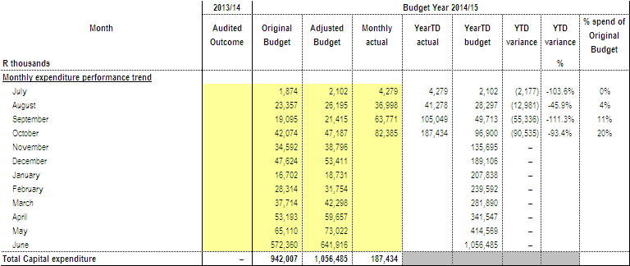

15.2 Capital Expenditure
BCMM has spent 19% inclusive of reclaimed vat (2013/14: 15%) of its 2014/15 rollover adjusted capital budget of R1.06 billion (2013/14: R856.36 million) with expenditure of R203.36 million (2013/14: R129.82 million) as at 31 October 2014. This reflects an improvement when compared to the same period in the previous financial year.

Refer to Annexure A – C5 for the breakdown per municipal vote, standard classification & funding; Annexure B – SC12 for monthly expenditure trends; SC13a for breakdown of asset classification for new assets and SC13b for breakdown on asset classification on renewal of existing asset).
A detailed schedule of the capital projects expenditure is outlined in Annexure E.

Table 29: Capital Expenditure per Funding Source against Budget

Funding | 2014/2015 Adjustment Budget | YTD Expenditure (VAT) incl) | Variance | % Exp.
Total Own Funding | 331,865,569 | 42,851,307 | 289,014,262 | 13%
DoE(Intergrated National Electrification Programme) | 27,000,000 | 13,583,254 | 13,416,746 | 50%
Department of Sports, Recreation, Arts and Culture c/o | 2,686,285 | 248,800 | 2,437,485 | 9%
Local Government, Traditional Affairs and Housing | 188,726 | 178,585 | 10,141 | 95%
Infrastructure Skills Development Grant | 100,000 | 0 | 100,000 | 0%
BCMET c/o | 256,818 | 0 | 256,818 | 0%
Leiden c/o | 458,860 | 0 | 458,860 | 0%
Neigbourhood Development Partnership Grant | 5,000,000 | 3,067,921 | 1,932,079 | 61%
Urban Settlement Development Grant | 639,824,500 | 125,815,692 | 514,008,808 | 20%
Human Settlement Development Grant | 49,103,948 | 17,616,381 | 31,487,567 | 36%
Total Grants | 724,619,137 | 160,510,633 | 564,108,504 | 22%
TOTAL PER FUNDING | 1,056,484,706 | 203,361,941 | 853,122,765 | 19%

Table 30: Actual Expenditure per Service against Budget

Services | 2014/2015 Adjustment Budget | YTD Expenditure (VAT) incl) | Variance | % Exp.
Water | 95,114,971 | 7,619,392 | 87,495,579 | 8%
Waste Water | 220,656,160 | 29,333,667 | 191,322,493 | 13%
Electricity | 137,747,400 | 30,420,480 | 107,326,920 | 22%
Roads and Stormwater | 188,000,000 | 60,091,340 | 127,908,660 | 32%
Housing | 100,776,115 | 38,233,494 | 62,542,621 | 38%
Transport Planning | 56,551,207 | 6,965,226 | 49,585,981 | 12%
Waste Management / Refuse | 95,783,621 | 5,335,080 | 90,448,541 | 6%
Amenities | 57,818,502 | 2,787,159 | 55,031,343 | 5%
Environmental Services | 10,000,000 | 0 | 10,000,000 | 0%
Health Services | 0 | 0 | 0 | 0%
Public Safety | 13,866,980 | 941,437 | 12,925,543 | 7%
Support Services | 47,872,082 | 4,712,068 | 43,160,014 | 10%
Other - BCM Fleet | 32,297,668 | 16,922,597 | 15,375,071 | 52%
 | 1,056,484,706 | 203,361,941 | 853,122,765 | 19%

Table 31: Actual Expenditure per Directorate against Budget

Directorate | 2014/2015 Rollover Adjustment Budget | YTD Expenditure (VAT) incl) | Variance ( VAT incl) | % Expenditure (VAT incl)
1. Executive Support Services | 6,846,757 | 287,453 | 6,559,304 | 4%
2. Municipal Manager's Office | 7,008,500 | 3,391,898 | 3,616,602 | 48%
3. Human Settlements | 100,830,255 | 38,293,243 | 62,537,012 | 38%
4. Directorate of Financial Services | 2,825,902 | 29,325 | 2,796,577 | 1%
5. Directorate of Corporate Services | 23,437,633 | 943,642 | 22,493,991 | 4%
6. Directorate of Engineering Services | 674,316,199 | 144,387,476 | 529,928,723 | 21%
7. Directorate of Development Planning | 46,525,207 | 6,965,226 | 39,559,981 | 15%
8. Directorate of Economic Development | 10,026,000 | 0 | 10,026,000 | 0%
9. Directorate of Health & Public Safety | 13,866,980 | 941,437 | 12,925,543 | 7%
10 .Directorate of Community Services | 163,865,123 | 8,122,239 | 155,742,884 | 5%
TOTAL DIRECTORATES | 1,049,548,556 | 203,361,941 | 846,186,615 | 19%
Asset Replacement | 6,936,150 |  | 6,936,150 | 0%
GRAND - TOTAL | 1,056,484,706 | 203,361,941 | 853,122,765 | 19%

15.3 Monthly Budget Statement – Capital Expenditure on New Assets by Asset Class
The capital programme performance tables provide summaries of capital expenditure by asset class and sub-class.

Table 32: SC13a Monthly budget Statement – capital expenditure on new assets
by asset class

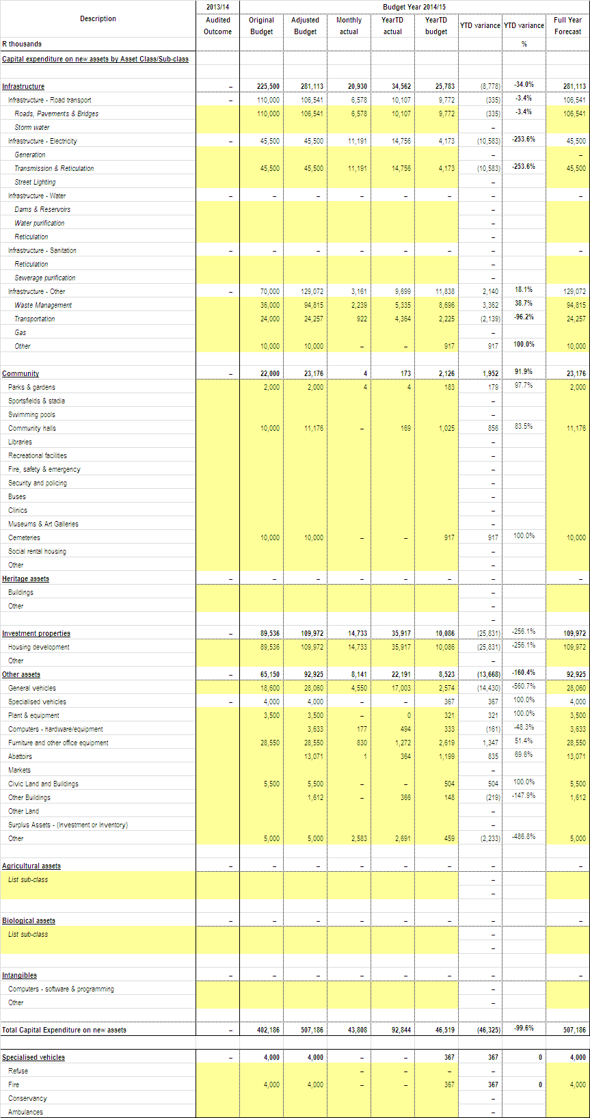
15.4 Monthly Budget Statement – Capital Expenditure on Renewal of Existing
Assets by Asset Class
Table 33: SC13b Monthly budget Statement – capital expenditure on renewal of existing assets by asset class

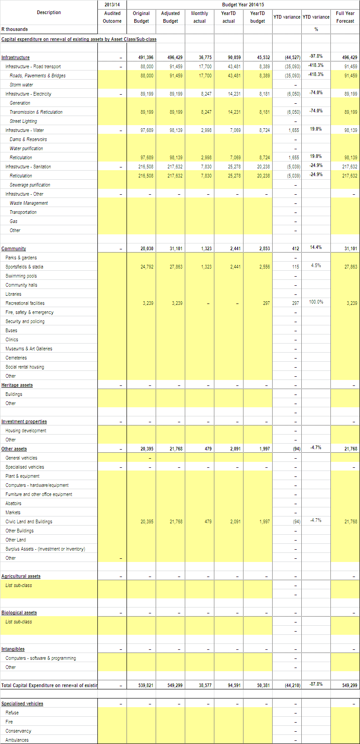

16. OTHER SUPPORTING DOCUMENTS
16.1 Operating Projects Expenditure

The Metro has spent 24%, inclusive of reclaimed vat (2013/14:12%) of its 2014/15 rollover adjustment budget of R288.44 million (2013/14: R357.01 million) with expenditure of R69.1 million as at 31 October 2014 (2013/14: R42.58 million). This reflects an improvement when compared to the same period in the previous financial year.

A detailed schedule of the operating projects expenditure is outlined in Annexure D. Below in tables 34 & 35 kindly find the summary for Annexure D.

Table 34: Operating Projects per Directorate

OPERATING PROJECTS PER DIRECTORATE | 2014/2015 Adjusted Budget | YTD Expenditure (VAT) incl | Variance | % Exp.
1. Executive Support Services | 1,755,165 | 239,247 | 1,515,918 | 14%
2. Municipal Manager's Office | 48,982,809 | 10,094,716 | 38,888,093 | 21%
3. Chief Operations Officer | 157,268,143 | 41,370,612 | 115,897,531 | 26%
4. Directorate of Financial Services | 42,961,602 | 6,235,293 | 36,726,309 | 15%
5. Directorate of Corporate Services | 14,364,938 | 2,503,084 | 11,861,854 | 17%
6. Directorate of Engineering Services | 2,000,000 | 0 | 2,000,000 | 0%
7. Directorate of Development Planning | 2,284,436 | 277,706 | 2,006,730 | 12%
8. Directorate of Economic Development | 13,439,408 | 5,743,379 | 7,696,029 | 43%
9. Directorate of Health & Public Safety | 277,788 | 0 | 277,788 | 0%
10. Directorate of Community Services | 5,103,534 | 2,640,620 | 2,462,914 | 52%
 | 288,437,823 | 69,104,656 | 219,333,167 | 24%

Table 35: Operating Projects per Funding Source

OPERATING PROJECTS PER FUNDING SOURCE | 2014/2015 Opex Adjusted Budget | 2014/2015 EXPENDITURE TO DATE VAT | 2014/2015 AVAILABLE BUDGET VAT | % EXPENDITURE VS BUDGET VAT
Total Own Funding | 82,958,512 | 11,691,479 | 71,267,033 | 14%
Department of Land Affairs c/o | 849,025 | 62,966 | 786,059 | 7%
Department of Local Government & Traditional Affairs | 4,790,672 | 918,489 | 3,872,183 | 19%
Department of Sport, Recreation and Arts and Culture | 37,438 | 0 | 37,438 | 0%
Department of Economic Development, Environmental Affairs and Tourism(DEDEAT) | 3,745,411 | 1,008,518 | 2,736,893 | 27%
European Commission | 500,000 | 0 | 500,000 | 0%
Expanded Public Works Programme Incentives Grant | 1,890,000 | 1,219,430 | 670,570 | 65%
Finance Management Grant | 1,500,000 | 477,936 | 1,022,064 | 32%
Human Settlement Development Grant | 142,523,295 | 39,823,981 | 102,699,314 | 28%
Infrastructure Skills Development Grant | 5,400,000 | 2,339,347 | 3,060,653 | 43%
Leiden | 136,315 | 0 | 136,315 | 0%
Local Government and Traditional Affairs | 6,101,371 | 2,635,182 | 3,466,189 | 43%
Premiers Fund | 67,421 | 0 | 67,421 | 0%
Trust Funds | 2,714,699 | 0 | 2,714,699 | 0%
Umsobomvu Youth Fund | 710,406 | 158,092 | 552,314 | 22%
Urban Settlement Development Grant | 33,464,500 | 8,750,695 | 24,713,805 | 26%
Vuna Awards | 1,048,758 | 0 | 1,048,758 | 0%
Total Grants | 205,479,311 | 57,394,636 | 148,084,675 | 28%
TOTAL PER FUNDING | 288,437,823 | 69,086,116 | 219,351,707 | 24%

17. INCOME AND EXPENDITURE REPORTS FOR DIRECTORATE OF HEALTH AND PUBLIC SAFETY & COMMUNITY SERVICES

17.1 HEALTH & PUBLIC SAFETY
Below is the table indicating the breakdown of the Cost Analysis indicating income and expenditure.

Table 36: Health & Public Safety – Cost Analysis
Health & Public Safety | Total Revenue | Employee Costs | Other Operating Expenditure | Repairs & Maintenance | Total Expenditure Excluding Capital
Office of the Dir P/Safety, Health, DM | 0 | 56,746 | 114,488 | 0 | 171,234
Support Services Office | 0 | 536,052 | 39,113 | 0 | 575,164
Health Administration | 0 | 986,275 | 184,102 | 0 | 1,170,377
Health Support | 0 | 0 | 23,135 | 0 | 23,135
Pharmacy | 0 | 0 | 6,622 | 0 | 6,622
Clinics | 0 | 0 | 441,626 | 11,449 | 453,075
Aids Training Information Centre | 0 | 0 | 62,068 | 0 | 62,068
Environmental Health | (394,406) | 4,920,242 | 920,975 | 17,171 | 5,858,388
Pest Control | (3,464) | 404,905 | 54,106 | 0 | 459,011
Pollution Control | 0 | 252,400 | 190,581 | 0 | 442,981
Educare Centres | 0 | 256,389 | 49,038 | 0 | 305,427
Public Safety Administration | 0 | 714,295 | 145,122 | 0 | 859,417
Fire and Rescue Services | (25,839,603) | 14,771,138 | 4,905,456 | 163,305 | 19,839,899
Security Services | (248) | 21,506,942 | 757,151 | 62,683 | 22,326,776
Traffic Administration | (19,059) | 5,411,338 | 5,865,007 | 179,762 | 11,456,108
Traffic Control | (5,865) | 6,109,171 | 251,607 | 5,479 | 6,366,257
Criminal Process | (1,459,501) | 990,916 | 47,043 | 0 | 1,037,958
Vehicle Test Station / Examination | (141,327) | 1,088,435 | 80,148 | 0 | 1,168,583
Vehicle Registration | (17,552,841) | 1,419,502 | 82,645 | 0 | 1,502,147
Drivers License Testing | (4,781,172) | 1,540,927 | 204,833 | 0 | 1,745,760
Traffic Technical Services | 0 | 1,207,441 | 71,307 | 70,456 | 1,349,204
Parking Areas / Meters | (1,709) | 1,614,542 | 22,252 | 0 | 1,636,794
Disaster Management | 0 | 522,903 | 258,712 | 3,853 | 785,468
Dog Tax Office | 70,713 | 224,812 | 18,309 | 2,424 | 245,545
Total | (50,128,481) | 64,535,370 | 14,795,446 | 516,581 | 79,847,398

17.2 COMMUNITY SERVICES
Below is the table indicating the breakdown of the Cost Analysis indicating income and expenditure.

Table 37: Community Services – Cost Analysis
Community Services | Total Revenue | Employee Costs | Other Operating Expenditure | Repairs & Maintenance | Total Expenditure Excluding Capital
Office of Dir. Community Serv. | 0 | 2,562,349 | 631,649 | 3,597 | 3,197,594
Community Services Administration | 0 | 819,147 | 88,134 | 0 | 907,281
Environmental Administration Support | 0 | 639,976 | 37,688 | 0 | 677,664
Environmental Services | (47,991) | 18,619,419 | 3,073,493 | 131,519 | 21,824,431
Environmental Conservation | 0 | 3,879,441 | 534,818 | 0 | 4,414,259
Environmental Workshop | 0 | 1,170,973 | 70,385 | 665,249 | 1,906,606
Interments | (2,519,966) | 6,682,051 | 2,057,639 | 60,490 | 8,800,179
Gompo Admin Building | 0 | 0 | 0 | 0 | 0
Integrated Environmental Management | 0 | 332,739 | 192,392 | 294 | 525,425
Arts & Cultural Serv:Admin | 0 | 2,761,986 | 195,575 | 16,512 | 2,974,072
Libraries | (104,782) | 5,621,253 | 525,391 | 1,497 | 6,148,140
Art Gallery | 0 | 266,420 | 27,842 | 0 | 294,262
Art Centres | 0 | 0 | 6,599 | 0 | 6,599
Halls | (3,128,792) | 3,577,467 | 3,498,128 | 30,312 | 7,105,907
Amenities Administration Support | 0 | 1,689,877 | 525,668 | 86,329 | 2,301,874
Sportsfields | (49,879) | 5,006,219 | 1,493,611 | 146,467 | 6,646,297
Swimming Pools | (38,894) | 3,082,523 | 414,352 | 48,247 | 3,545,121
Aquarium | (49,333) | 2,389,178 | 413,839 | 35,719 | 2,838,737
Zoo | (501,322) | 1,576,002 | 584,485 | 92,111 | 2,252,598
Beaches | (21,303) | 4,026,267 | 892,842 | 221,328 | 5,140,437
Resorts | (439,833) | 1,619,433 | 467,171 | 138,088 | 2,224,693
Cleansing Administration Support | 0 | 2,961,488 | 5,366,855 | 980,228 | 9,308,571
Refuse Removal | (115,724,410) | 13,281,407 | 43,606,882 | 3,525,383 | 60,413,673
Waste Disposal Sites | (935,960) | 583,798 | 1,084,453 | 0 | 1,668,252
Street Sweeping | (3,205) | 13,594,020 | 251,356 | 0 | 13,845,375
Public Conveniences | 0 | 1,686,773 | 656,989 | 0 | 2,343,762
EL Regional Waste Disposal Site & Transfer Station | 0 | 2,141,263 | 6,233,990 | 0 | 8,375,253
Total | (123,565,670) | 100,571,466 | 72,932,227 | 6,183,368 | 179,687,061

18. MUNICIPAL MANAGER’S QUALITY CERTIFICATION

QUALITY CERTIFICATE

I, …………………………………, The City Manager of Buffalo City Metropolitan Municipality do hereby certify that –

- The monthly budget statement (Section 71 Report)
- Quarterly report on the implementation of the budget and financial state of affairs of the municipality
- Mid-year budget and performance assessment

for the period ending October 2014 has been prepared in accordance with the Municipal Finance Management Act 2003 and Regulations made under that Act.

Print name: ...........................................

City Manager of Buffalo City Metropolitan Municipality, BUF

Signature: ..........................................

Date: ...............................................

ANNEXURES:

Annexure A
C1 Monthly Budget Statement - Summary
C2 Monthly Budget Statement - Financial Performance (Std Classification)
C3 Monthly Budget Statement - Financial Performance (By Municipal Vote)
C4 Monthly Budget Statement - Financial Performance (Revenue and Expenditure)
C5 Monthly Budget Statement - Capital Expenditure (Municipal Vote, Std
Classification and Funding)
C6 Monthly Budget Statement - Financial Position
C7 Monthly Budget Statement - Cash Flow

Annexure B
SC1 Material Variance Explanation
SC2 Performance Indicators
SC3 Aged Debtors
SC4 Aged Creditors
SC5 Investment Portfolio
SC6 Transfers and Grants Receipts
SC7 (1) Transfers and Grants Expenditure
SC7 (2) Expenditure against approved rollovers
SC8 Councillor and Staff Benefits
SC9 Actuals and Revised Targets for Cash Receipts
SC12 Capital Expenditure trend
SC13a Capital Expenditure on New Assets by Class
SC13b Capital Expenditure on Renewal of Existing Assets by Class
SC13c Expenditure on Repairs and Maintenance by Asset Class
SC13d Depreciation by Asset Class

Annexure C
Schedule of Borrowings

Annexure D
Operating expenditure report

Annexure E
Capital expenditure report

